**Final Project Topic: Google Cloud Dataflow Real-time Service for Batch and Stream Processing**

**Hanjiao Qiu**

**Abstract**

Google Cloud Dataflow is a fully-managed cloud service and programming model for batch and streaming big data processing. It can be used to process massive-scale, unbounded and unordered data. It also supports the unaligned, event-time-ordered windows modern data consumers require. This project will demonstrate how to build your streaming and batch processing pipeline using Cloud SDK and show how does Cloud Dataflow run and optimize your pipeline. Moreover, it will integrate with Cloud Storage, Cloud Pub/Sub and BigQuery for seamless data processing.

**Problem Statement**

Process massive HTTP Archive dataset using Google Cloud Dataflow. Analyze the trends in web technology and measure the website performance, such as: 1) Search and sort the popular CDN (Content Delivery Network) providers by building Dataflow pipeline. 2) Compute the distribution of requests for different image format. 3) Calculate the average downloaded content length based on content type. 4) Use Dataflow pipeline derived data as a side input to filter image object whose size is larger than global mean value. 5) Use Dataflow time-based windowing model to aggregate total number of requests per page.

**Dataset**

HTTP Archive data (<http://httparchive.org/)>, also available through BigQuery. (40+ GB, csv)

**Technology Used**

Google Cloud Dataflow SDK, Eclipse IDE version 4.5.1, Java version 1.8.0.

**Overview of steps**

1. Environment setup: Configure Eclipse, install Dataflow SDK, run example.
2. Prepare the dataset, load in data from Cloud Storage or BigQuery.
3. Use the Dataflow Java SDK to build a linear pipeline to process HTTP Archive data.
4. Apply more sophisticated models to do real-time stream processing.
   1. Branching a pipeline: use side outputs, process input once, multiple outputs.
   2. Window model for processing bounded / unbounded streaming data.
5. Validate the results using BigQuery. Analyze and visualize the results in D3.

**Issues & Lessons learned**

With the practice of windowing model, we can implement more complicated models. Cloud Dataflow data transforms also supports triggering, incremental processing model and so on. Highly recommend reading the official research paper and try using them to solve real world problems.

**Video URL**

Short video: <https://youtu.be/Jt5J4SMQNko>

Full video: <https://youtu.be/kjFoB6ZM9Iw>

**Cloud Dataflow Features**

* **Automated resource management**

Fully automates management of required processing resources.

* **On demand**

Resources are scaled to your business, no reserved compute instances needed.

* **Intelligent work scheduling**

Automated and optimized work partitioning, dynamically rebalance lagging work.

* **Horizontal auto scaling**

Meet optimum throughput requirements results in better overall price-to-performance.

* **Unified programming model**

The Dataflow API supports MapReduce like operations, powerful data windowing, and fine grained correctness control regardless of data source.

* **Open source**

Developers can extend the Dataflow programming model on Java-based Dataflow SDK.

* **Real-time monitoring**

Provides statistics such as pipeline throughput and lag, consolidated worker log inspection.

* **Integrated**

Cloud Storage, Pub/Sub, Cloud Bigtable, and BigQuery for seamless data processing.

* **Reliable & consistent processing**

Provides built-in support for fault-tolerant execution that is consistent and correct.

**Detailed Steps**

1. Run an example pipeline from Eclipse IDE to ensure the correct environment setup.

Reference: <https://cloud.google.com/dataflow/docs/quickstarts/quickstart-java-eclipse>

* 1. Go to the Google Cloud Platform console, accept the terms of service and create a new project. Before loading the data, sign up for the free tier and set up billing in the console.

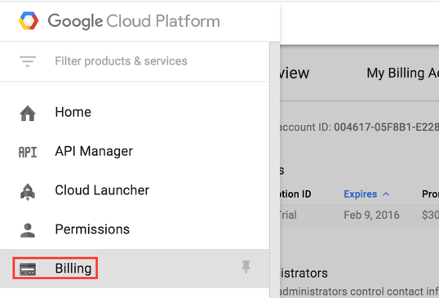 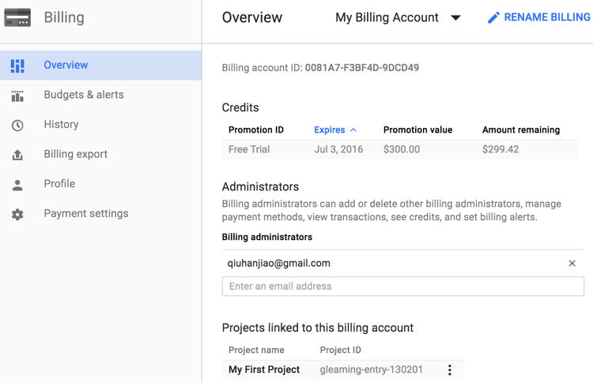

* 1. Enable the Cloud Dataflow, Compute Engine, Cloud Logging, Cloud Storage, Cloud Storage JSON, BigQuery, Cloud Pub/Sub, and Cloud Datastore APIs.

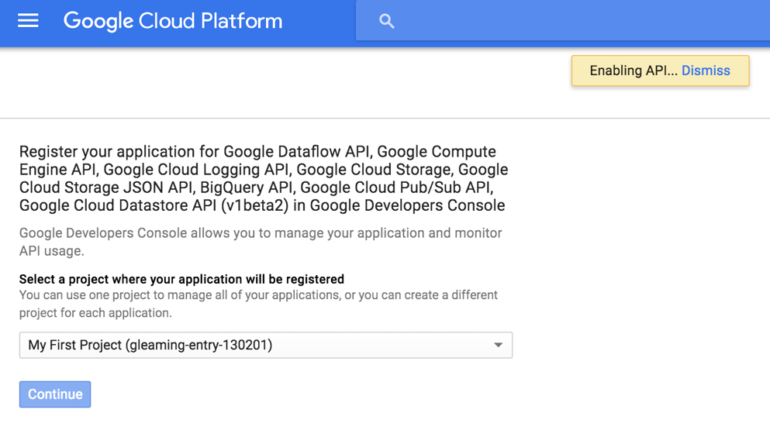

* 1. Install the Cloud SDK. (<https://cloud.google.com/sdk/)>
  2. Install the Cloud Dataflow plugin for Eclipse.

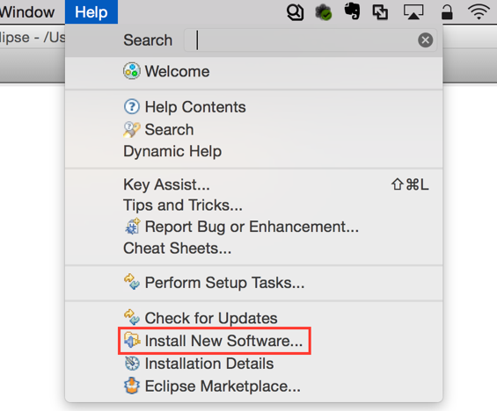

Select **Help -> Install New software**.

In the **Work with** text box, enter **https://dl.google.com/dataflow/eclipse/**.

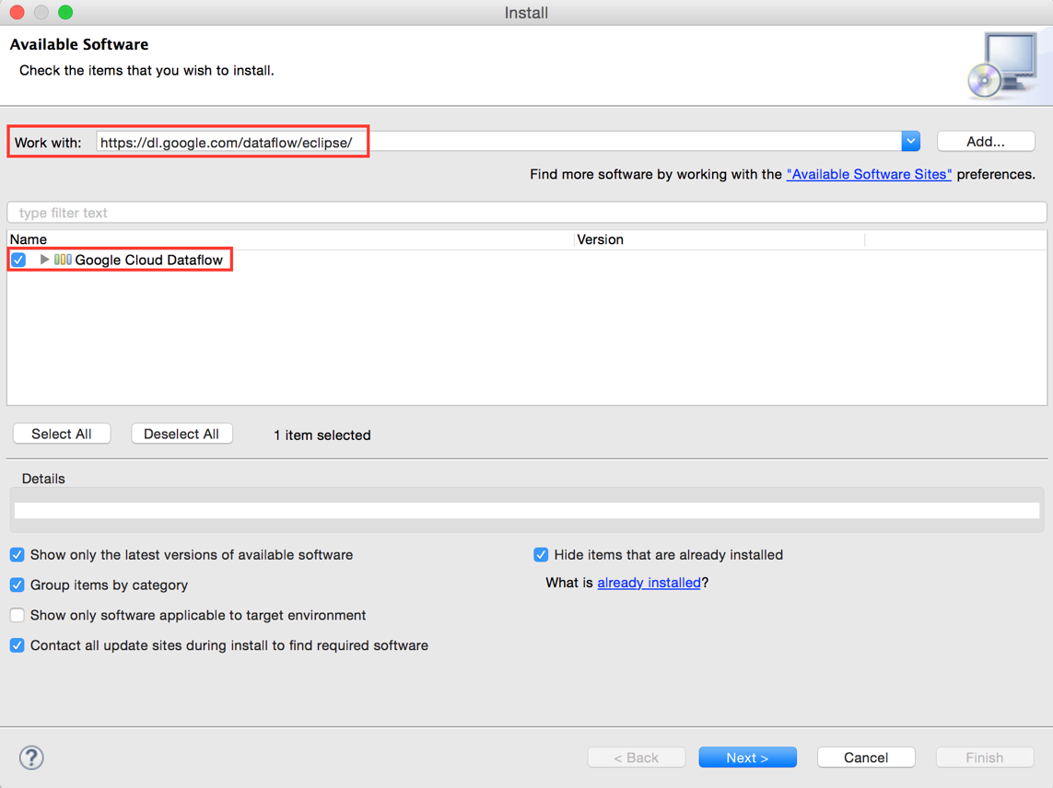

* 1. Create a Cloud Dataflow project in Eclipse.

Select **New -> Project**.

In the **wizards** list, expand **Google Cloud Platform** and select **Cloud Dataflow Java Project**.

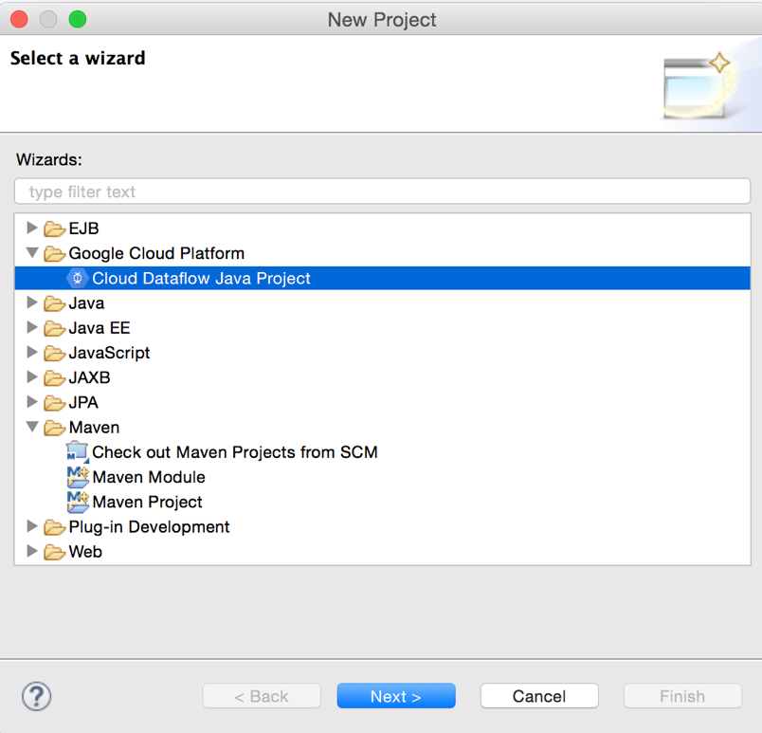

Select **Example pipelines** for **Project Template**.

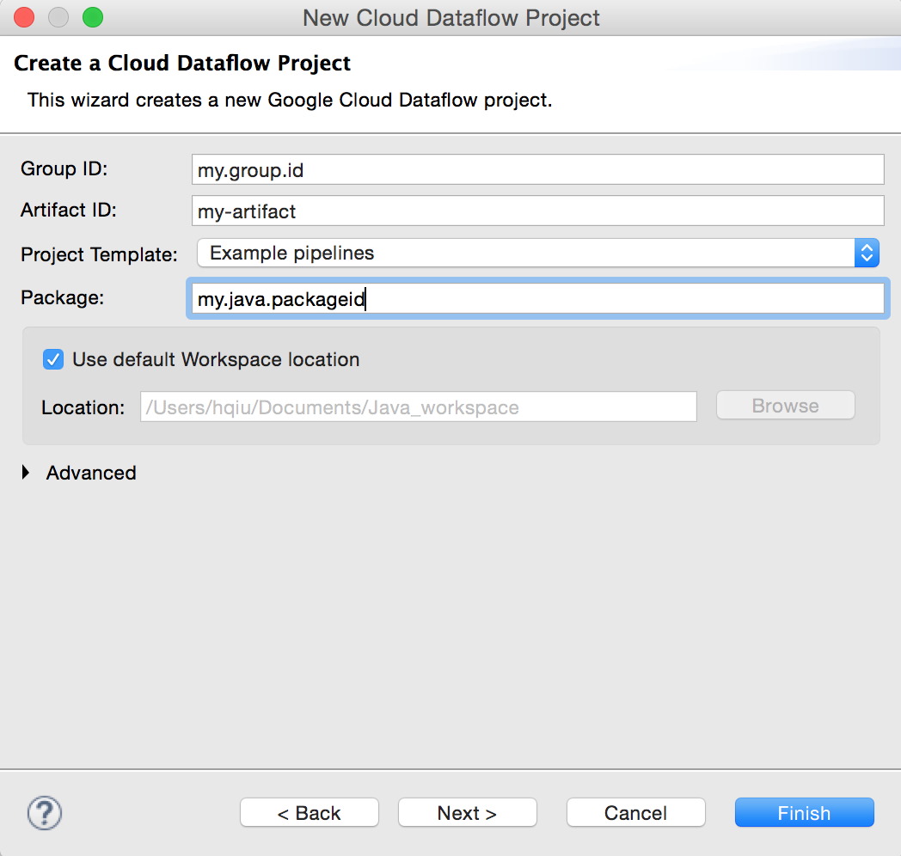

Enter the Cloud Platform Project name for **Cloud Platform Project ID**.

Enter a unique name for a Cloud Storage bucket for **Cloud Storage Staging Location**.

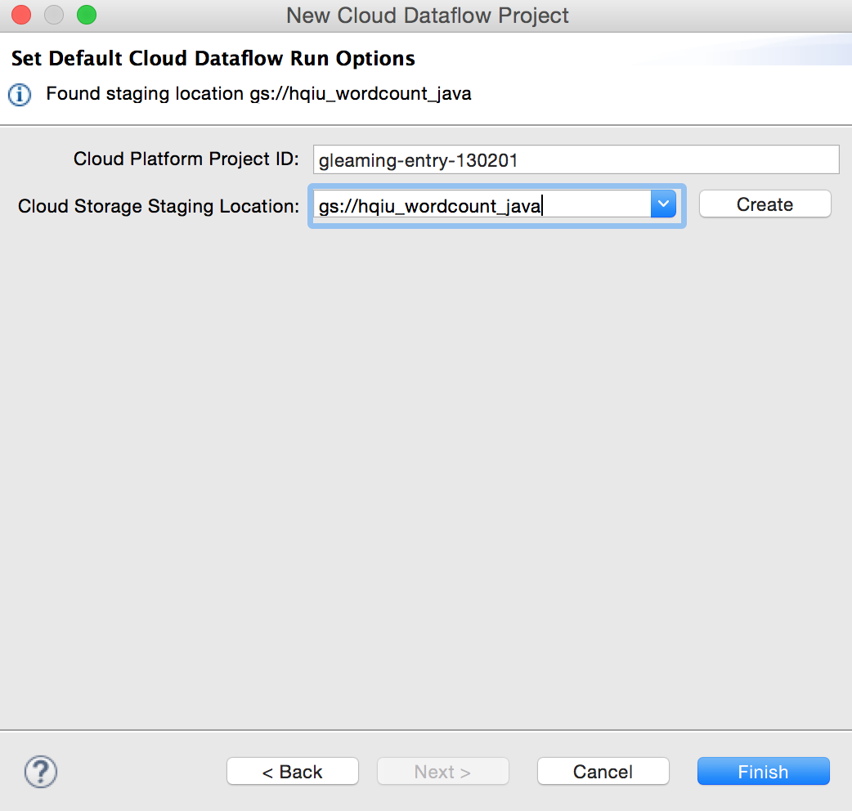

The example source code can be found here:

<https://github.com/GoogleCloudPlatform/DataflowJavaSDK-examples/blob/master/src/main/java/com/google/cloud/dataflow/examples/WordCount.java>

* 1. Run the WordCount example pipeline on the Cloud Dataflow in Eclipse.

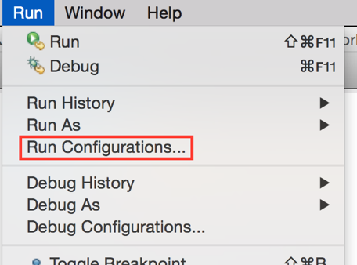

Select **Dataflow Pipeline** and click the **New Launch Configuration** button.

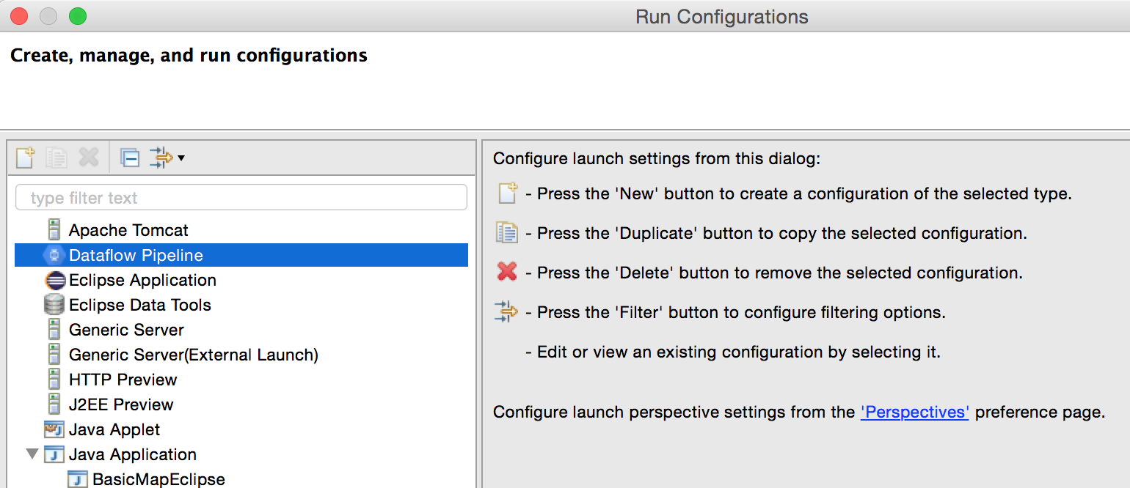

Set the main class **my.java.packageid.WordCount**.

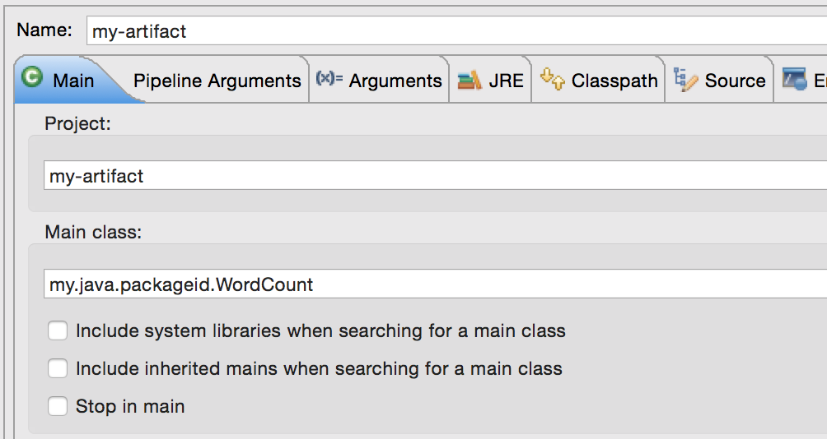

In **Pipeline Arguments ->** **Runner** category, select **BlockingDataflowPipelineRunner**.

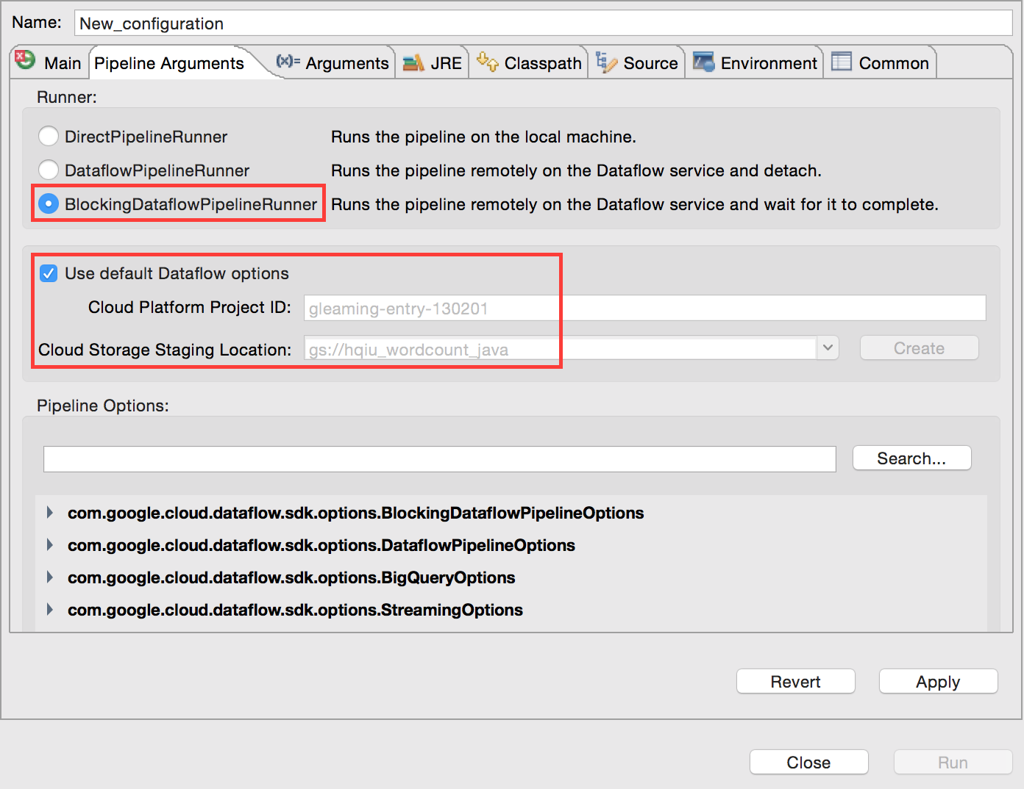

**Apply** and **Run**. We could create the Cloud Storage bucket in advance.

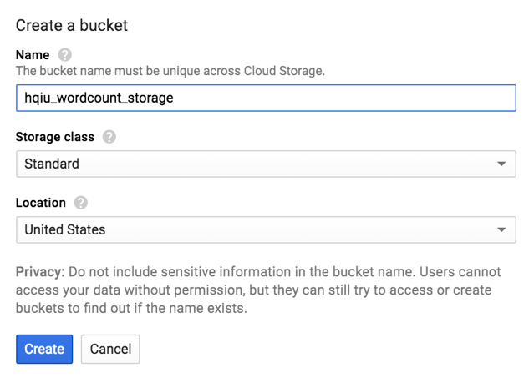

* 1. View the job status in Cloud Dataflow Monitoring UI.

<https://console.cloud.google.com/dataflow?_ga=1.123437259.1147230397.1461548913>

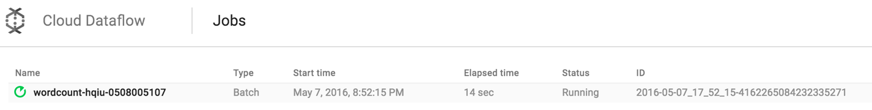

Status will change from **Running** to **Succeeded** afterwards.

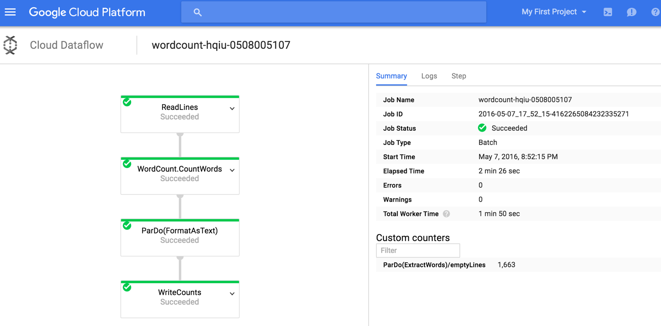

Output from Eclipse console:

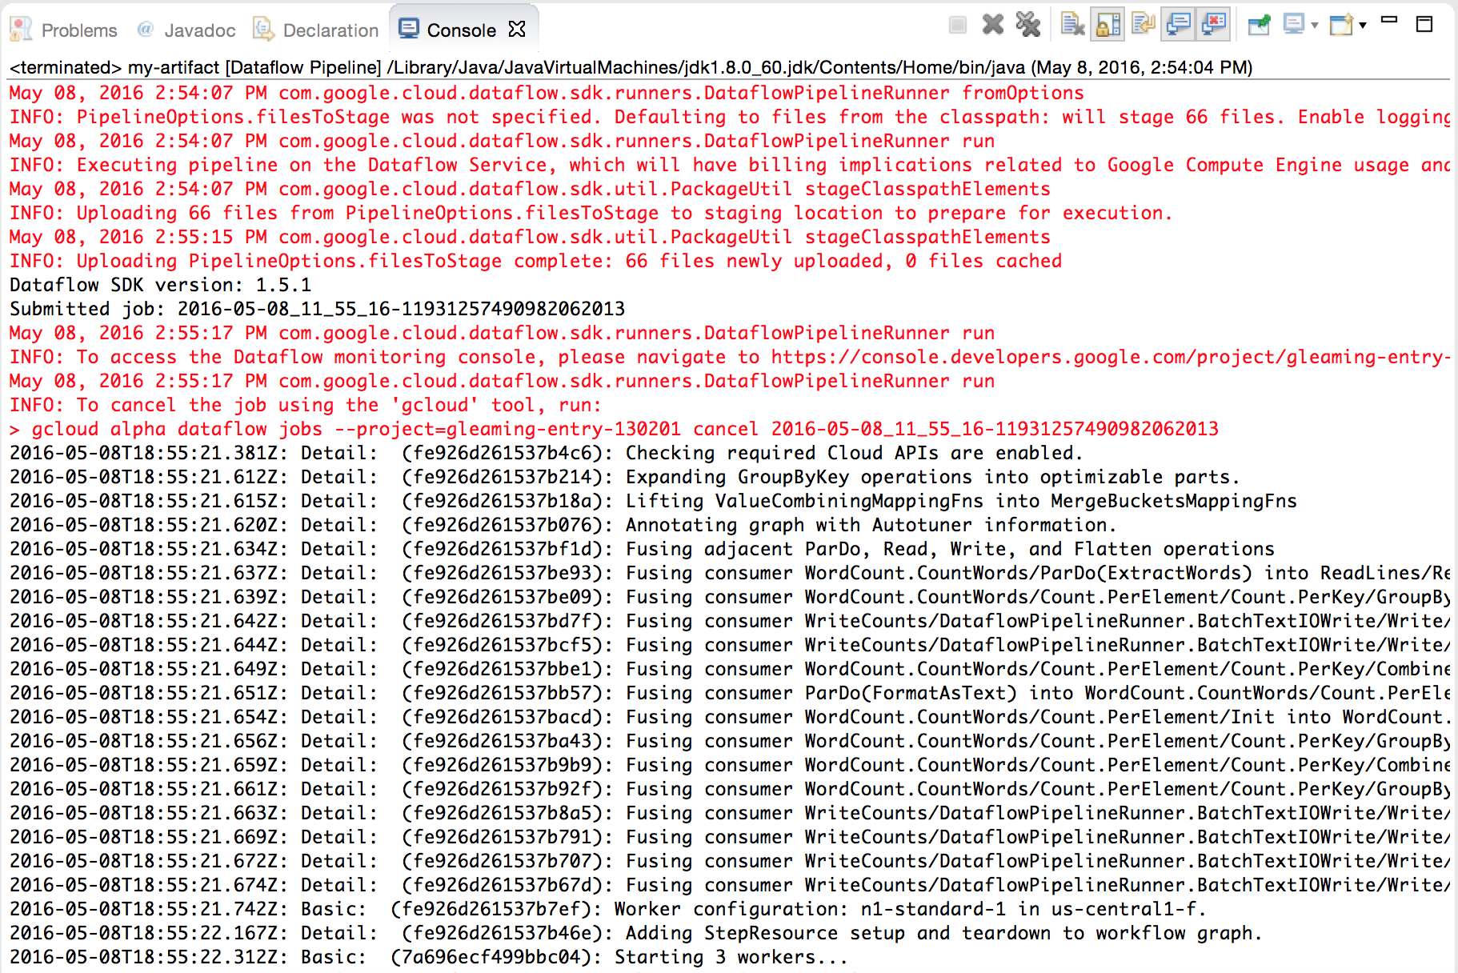

We can see lots of staging files has been uploaded to the Cloud Storage bucket.

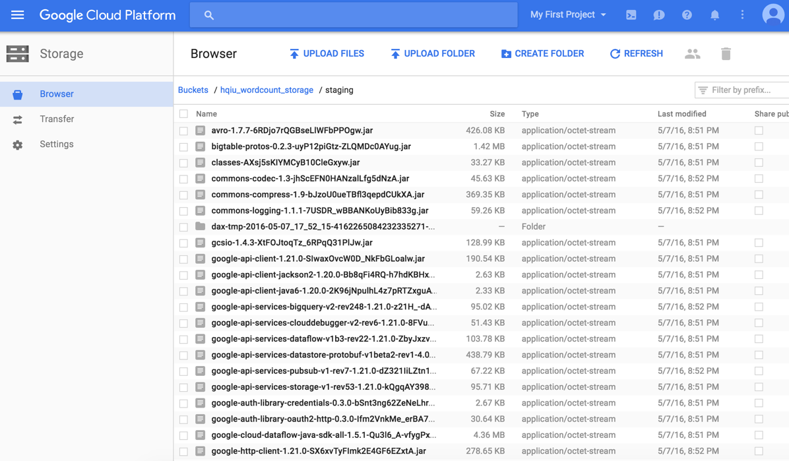

Output file contains the word count pairs.

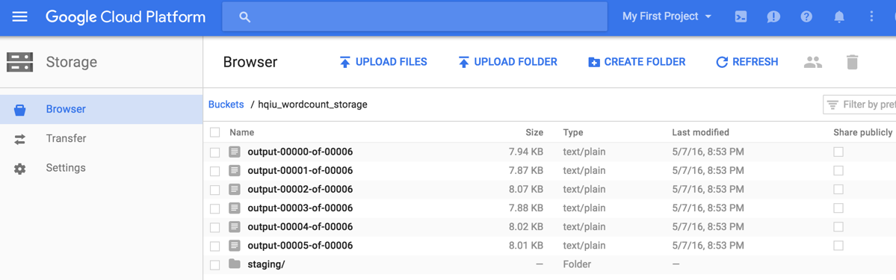

View logs in Google Cloud Platform console.

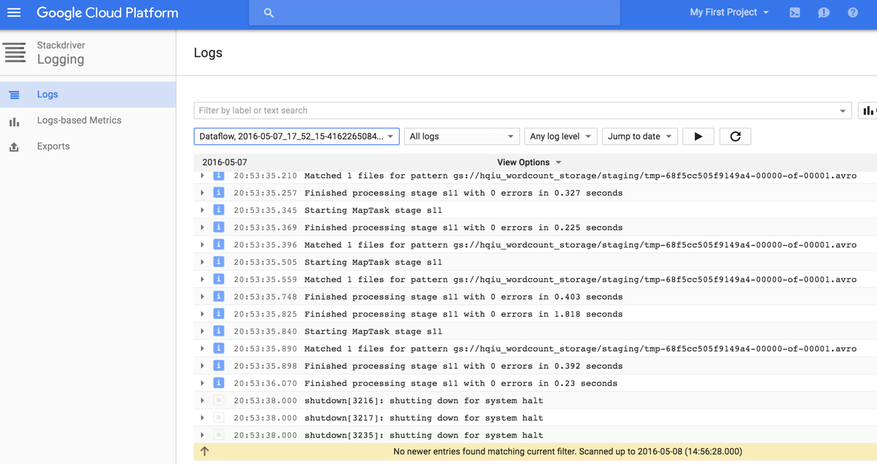

The following self developed code are all run using similar configuration and sequences like above. The code manifest:

|  |  |
| --- | --- |
| Functionality | Source file |
| Search and sort popular CDN | BigQueryPopularCDN.java |
| Compute total requests for different image format | ImgRqstByFormat.java |
| Calculate average content length based on type | AvgResponseSize.java |
| Filter image objects based on size | FilterImgObjSize.java |
| Aggregate total number of requests per page | RqstsPerPage.java  WindowedRqstsPerPage.java |

1. Search and sort the popular CDN (Content Delivery Network) providers by building linear Dataflow pipeline.
   1. Load in the data set called “HTTPArchive” (<http://httparchive.org/index.php)> through **Google BigQuery**. The HTTP Archive tracks how the web is built. It uses distributed web crawler to extract web data twice a month. We can analyze the trends in web technology, interesting statics and website performance through the data. We will solve our problems using this dataset!

Load in this data set by click the down narrow icon next to **My Project**. Go to **Switch to project -> Display project -> Add Project**, enter **httparchive**. The dataset **httparchive:runs** will show on the left under **My Project**.

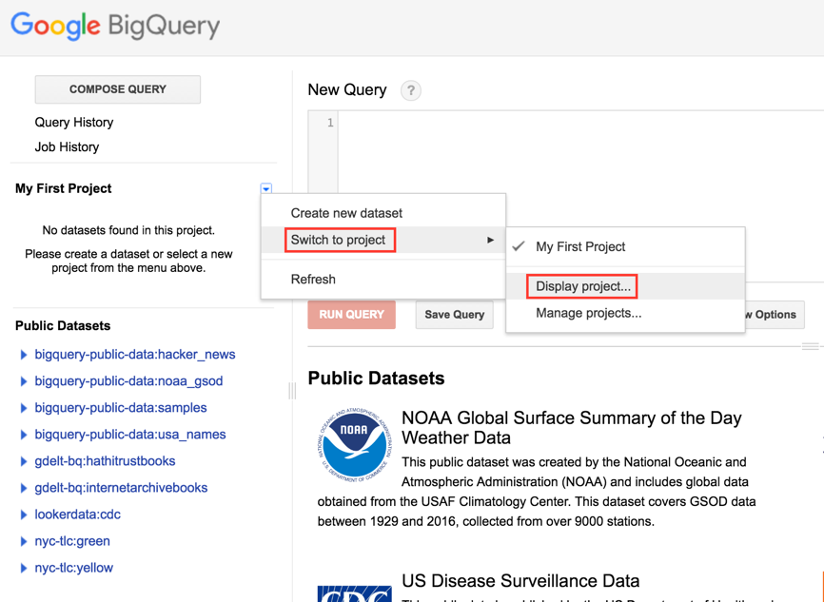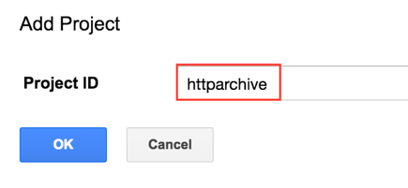

The data is added in. We can choose the latest dataset **2016_04_15_requests**, which is **42.1**GB.

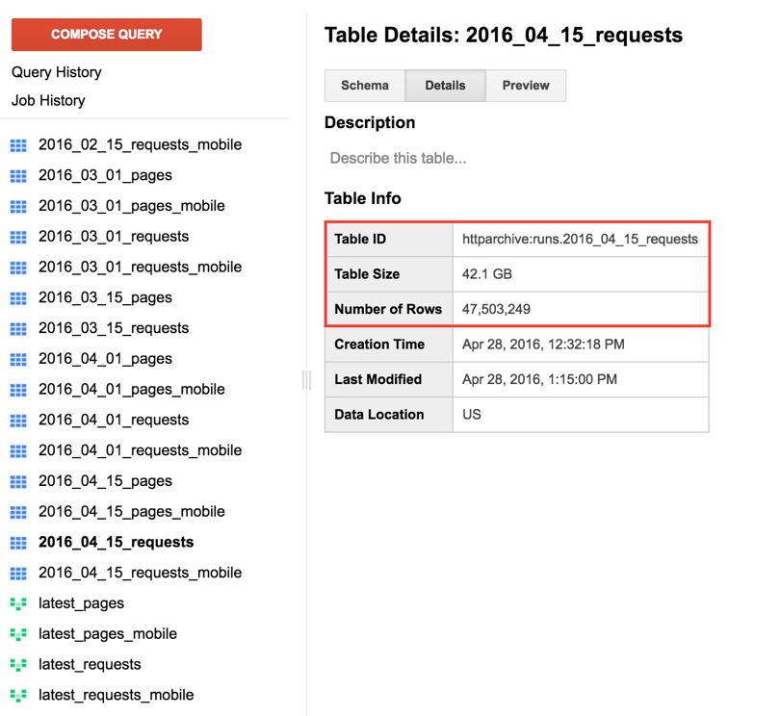

The Google BigQuery provides an easy way to preview data, select data and validate our results. It can be used to process massive big data too.

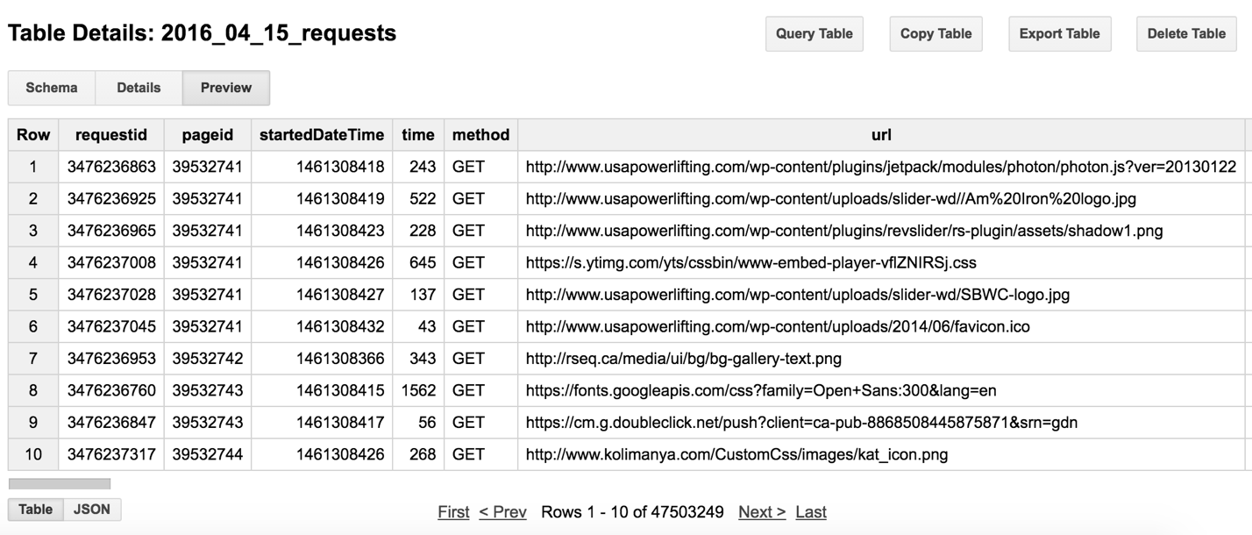

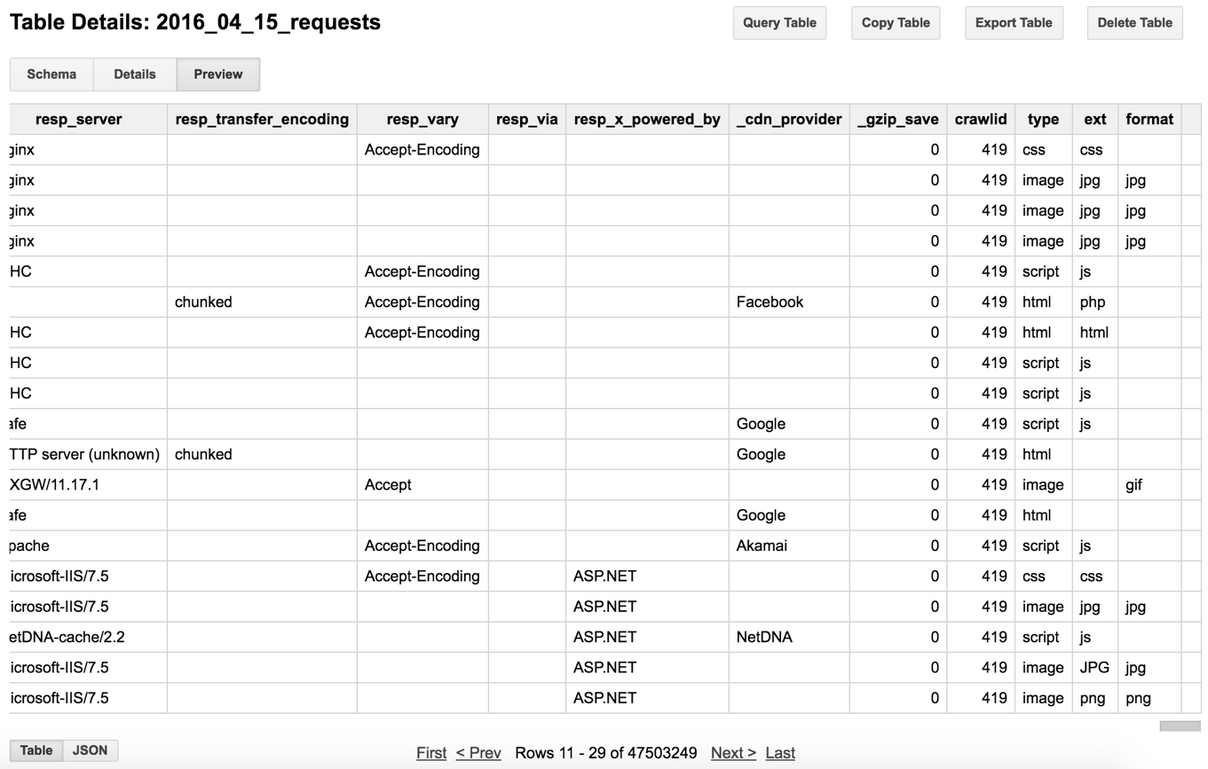

* 1. Design and construct our own pipeline to solve the problem.

Reference: <https://cloud.google.com/dataflow/pipelines/design-principles>

The **Cloud Dataflow programming model** contains:

* **Pipelines**

A **pipeline**represents a data processing job. It can be built by writing a program using a Dataflow SDK. It consists of a set of operations that can read a source of input data, transform that data, and write out the resulting output. The data and transforms in a pipeline are unique that pipeline. They can not share data or transforms.

* **PCollections**

The Dataflow SDKs use a specialized class called **PCollection**to represent data in a pipeline. A **PCollection**represents a multi-element data set. Dataflow’s [transforms](https://cloud.google.com/dataflow/model/transforms) use **PCollections** as inputs and outputs. If you want to work with data in your pipeline, it must be in the form of a **PCollection**. Each **PCollection**is owned by a specific **Pipeline**object, and only that **Pipeline**object can use it.

* **Transforms**

A **transform**represents a step, or a processing operation that transforms data. A transform can perform nearly any kind of processing operation, including performing mathematical computations on data, converting data from one format to another, grouping data together, reading and writing data, filtering data to output only the elements you want, or combining data elements into single values.

* **Pipeline I/O**

When you create a pipeline, you’ll often need to read data from some external source, such as a file in [Google Cloud Storage](https://cloud.google.com/storage/docs) or a BigQuery table. The Dataflow SDKs provide transforms that can read data from an external source or write data to an external sink.

Reference code:

<https://github.com/GoogleCloudPlatform/DataflowJavaSDK-examples/blob/master/src/main/java/com/google/cloud/dataflow/examples/cookbook/BigQueryTornadoes.java>

A pipeline can be significantly complex. It can have multiple input sources, multiple output sinks, and its operations (transforms) can output multiple **PCollections**. The simplest pipelines represent a linear flow of operations like below. We will first build this linear pipeline.

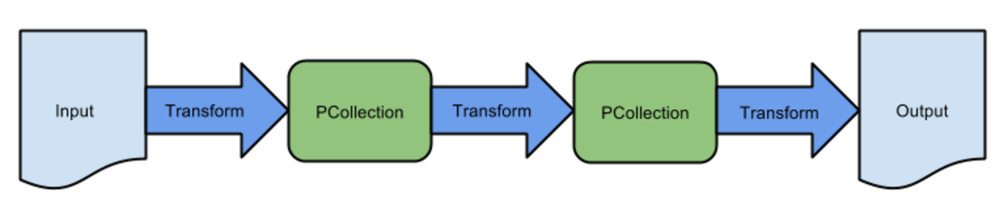

The sequences to code implementation can be:

* Create the pipeline object.
* Read data into the pipeline.
* Apply transforms to process pipeline data.
* Write / Output the final pipeline data.
* Run the pipeline.

Source file: BigQueryPopularCDN.java

The library needs to import:

**package** my.java.packageid;

**import** com.google.api.services.bigquery.model.TableFieldSchema;

**import** com.google.api.services.bigquery.model.TableRow;

**import** com.google.api.services.bigquery.model.TableSchema;

**import** com.google.cloud.dataflow.sdk.Pipeline;

**import** com.google.cloud.dataflow.sdk.io.BigQueryIO;

**import** com.google.cloud.dataflow.sdk.options.Default;

**import** com.google.cloud.dataflow.sdk.options.Description;

**import** com.google.cloud.dataflow.sdk.options.PipelineOptions;

**import** com.google.cloud.dataflow.sdk.options.PipelineOptionsFactory;

**import** com.google.cloud.dataflow.sdk.options.Validation;

**import** com.google.cloud.dataflow.sdk.transforms.Count;

**import** com.google.cloud.dataflow.sdk.transforms.DoFn;

**import** com.google.cloud.dataflow.sdk.transforms.PTransform;

**import** com.google.cloud.dataflow.sdk.transforms.ParDo;

**import** com.google.cloud.dataflow.sdk.values.KV;

**import** com.google.cloud.dataflow.sdk.values.PCollection;

**import** java.util.ArrayList;

**import** java.util.List;

Main class object **BigQueryPopularCDN**:

**public** **class** BigQueryPopularCDN {

// Default data set: httparchive:runs.2016_04_15_requests

**private** **static** **final** String ***HTTP_ARCHIVE_TABLE*** =

"httparchive:runs.2016_04_15_requests";

**private** **static** **final** String ***CDN_PROVIDER_TABLE*** =

"gleaming-entry-130201:hqiu_httparchive_result.CDNProviderPopularity";

/**

* Examines each row in the input table. If a CDN provider is recorded

* in that sample, the name of the CDN provider is the output.

*/

**static** **class** ExtractCDNProviderFn **extends** DoFn<TableRow, String> {

@Override

**public** **void** processElement(ProcessContext c){

TableRow row = c.element();

**if** ((String) row.get("_cdn_provider") != **null** &&

! ((String) row.get("_cdn_provider")).isEmpty()) {

c.output((String) row.get("_cdn_provider"));

}

}

}

/**

* Prepares the data for writing to BigQuery by building a TableRow object containing the

* CDN Providers and the occurrences of the providers.

*/

**static** **class** FormatCountsFn **extends** DoFn<KV<String, Long>, TableRow> {

@Override

**public** **void** processElement(ProcessContext c) {

TableRow row = **new** TableRow()

.set("provider", c.element().getKey())

.set("number", c.element().getValue());

c.output(row);

}

}

In the Dataflow SDKs, pipelines use a specialized collection class called **PCollection** to represent their input, intermediate, and output data. **PCollections** can be used to represent data sets of virtually any size. **PCollections** are specifically designed to support parallelized processing.

Each **transform** takes one or more **PCollections** as input, changes or otherwise manipulates the elements of that **PCollection**, and produces one or more new **PCollections** as output.

To apply a transform, you call the **apply** method on each **PCollection** that you want to process, passing the desired transform object as an argument.

**ParDo** is the **core parallel processing operation** in the Dataflow SDKs. It’s used for generic parallel processing. The **ParDo** processing style is similar to what happens inside the "Mapper" class of a Map/Shuffle/Reduce-style algorithm: **ParDo** takes each element in an input PCollection, performs some processing function on that element, and then emits some key value pairs like zero, one, or multiple elements to an output PCollection.

The code above apply **ParDo** to the **PCollection** we want to transform, and save the return value as a **PCollection** of the appropriate type.

The argument that you provide to **ParDo**must be a subclass of a specific type provided by the Dataflow SDK, called **DoFn**. A **DoFn** processes one element at a time from the input **PCollection**. **DoFn** must override the element-processing method **processElement**.

The Dataflow Java SDK handles extracting each element and passing it to **DoFn** subclass. When overriding **processElement**, the **override** method must accept an object of type **ProcessContext**, which allows you to access the element that you want to process. We can access the element that’s passed to **DoFn** by using the method **ProcessContext.element()**.

If the elements in **PCollection** are key/value pairs, we can access the key and value by using **ProcessContext.element().getKey()** and **ProcessContext.element().getValue()**.

/**

* Takes rows from a table and generates a table of counts.

*

* The output contains the total number of CDN provides found in each requests in

* the following schema:

* <ul>

* <li>provider: string</li>

* <li>number: integer</li>

* </ul>

*/

**static** **class** CountCDNProviders

**extends** PTransform<PCollection<TableRow>, PCollection<TableRow>> {

@Override

**public** PCollection<TableRow> apply(PCollection<TableRow> rows) {

// row... => CDN provider...

PCollection<String> CDNProviders = rows.apply(

ParDo.*of*(**new** ExtractCDNProviderFn()));

// CDN provider... => <CDN provider,count>...

PCollection<KV<String, Long>> CDNProviderCounts =

CDNProviders.apply(Count.<String>*perElement*());

// <CDN provider,count>... => row...

PCollection<TableRow> results = CDNProviderCounts.apply(

ParDo.*of*(**new** FormatCountsFn()));

**return** results;

}

}

A Dataflow program often starts by creating a **Pipeline** object and pass it some **configuration options**. Each Pipeline object is an independent entity that encapsulates both the data the pipeline operates over and the transforms that get applied to that data.

/**

* Options supported by {@link BigQueryPopularCDN}.

*

* <p>Inherits standard configuration options.

*/

**private** **static** **interface** Options **extends** PipelineOptions {

@Description("Table to read from, specified as "

+ "<project_id>:<dataset_id>.<table_id>")

@Default.String(***HTTP_ARCHIVE_TABLE***)

String getInput();

**void** setInput(String value);

@Description("BigQuery table to write to, specified as "

+ "<project_id>:<dataset_id>.<table_id>. The dataset must already exist.")

@Default.String(***CDN_PROVIDER_TABLE***)

@Validation.Required

String getOutput();

**void** setOutput(String value);

}

Constructing and running a **pipeline** with three **transforms**: a **transform** to read in some data, a **transform** to do some processing, and a **transform** to write out the results.

The first call to **apply** invokes a root transform to create a **PCollection** by reading data from a file. Each subsequent call to apply gets called on each resulting **PCollection** in turn.

Once you have constructed your pipeline, you use the **run** method to execute the pipeline. Pipelines are executed **asynchronously**: the program you create sends a specification for your pipeline to a pipeline runner, which then constructs and runs the actual series of pipeline operations.

**public** **static** **void** main(String[] args) {

Options options = PipelineOptionsFactory.*fromArgs*(args).withValidation().as(Options.**class**);

Pipeline p = Pipeline.*create*(options);

// Build the table schema for the output table.

List<TableFieldSchema> fields = **new** ArrayList<>();

fields.add(**new** TableFieldSchema().setName("provider").setType("STRING"));

fields.add(**new** TableFieldSchema().setName("number").setType("INTEGER"));

TableSchema schema = **new** TableSchema().setFields(fields);

p.apply(BigQueryIO.Read.*from*(options.getInput()))

.apply(**new** CountCDNProviders())

.apply(BigQueryIO.Write

.*to*(options.getOutput())

.withSchema(schema)

.withCreateDisposition(BigQueryIO.Write.CreateDisposition.***CREATE_IF_NEEDED***)

.withWriteDisposition(BigQueryIO.Write.WriteDisposition.***WRITE_TRUNCATE***));

p.run();

}

}

Set up the run configuration like before and run the code:

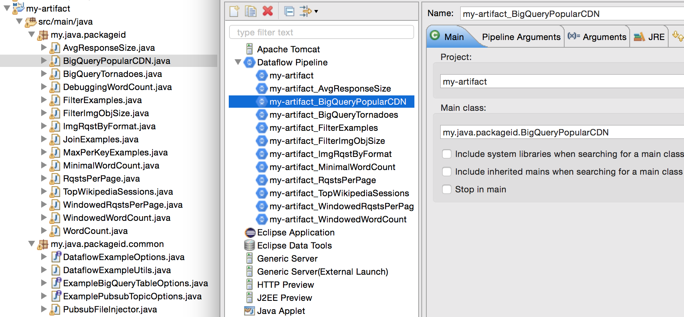

We can setup the pipeline options in **Pipeline Arguments**, such as increasing the number of workers to 5 through (default is 3):

**com.google.cloud.dataflow.sdk.options.DataflowPipelineWorkersPoolOptions**

**-> numWorkers = 5**

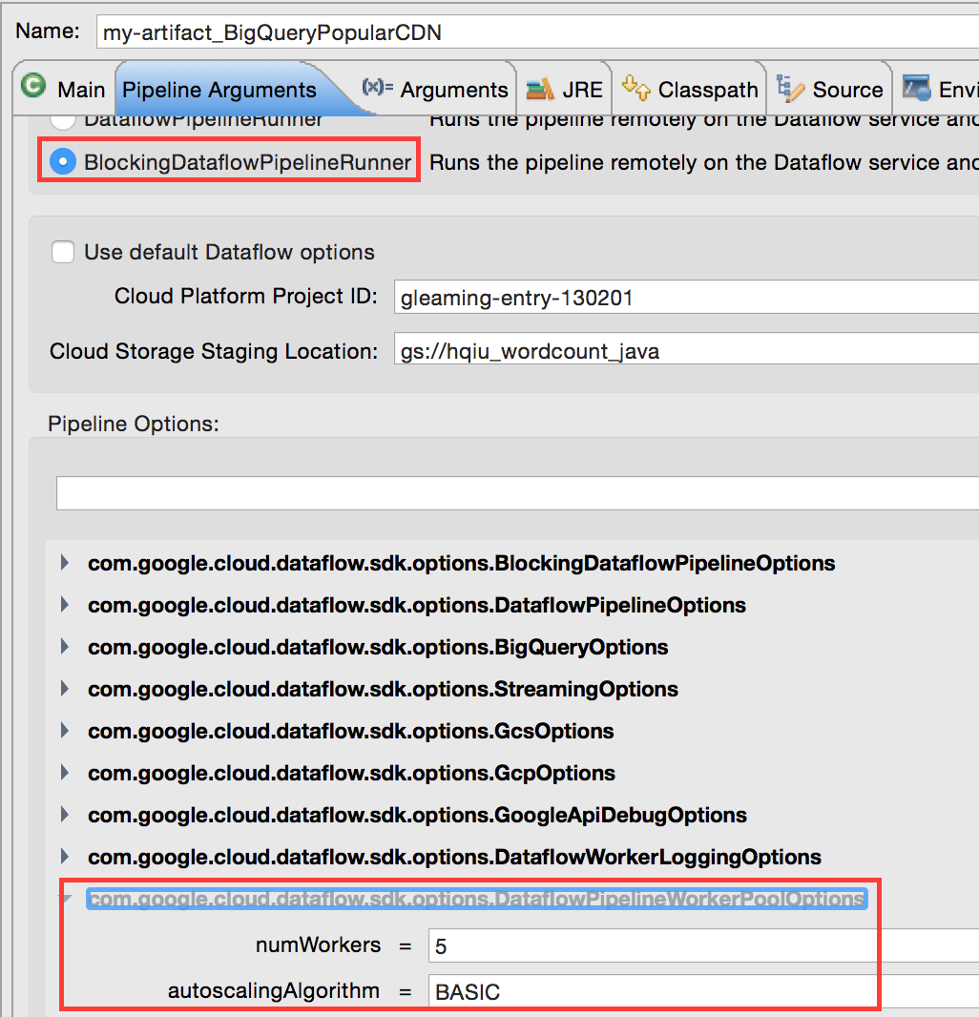

Job status and flow structure from Cloud Dataflow console:

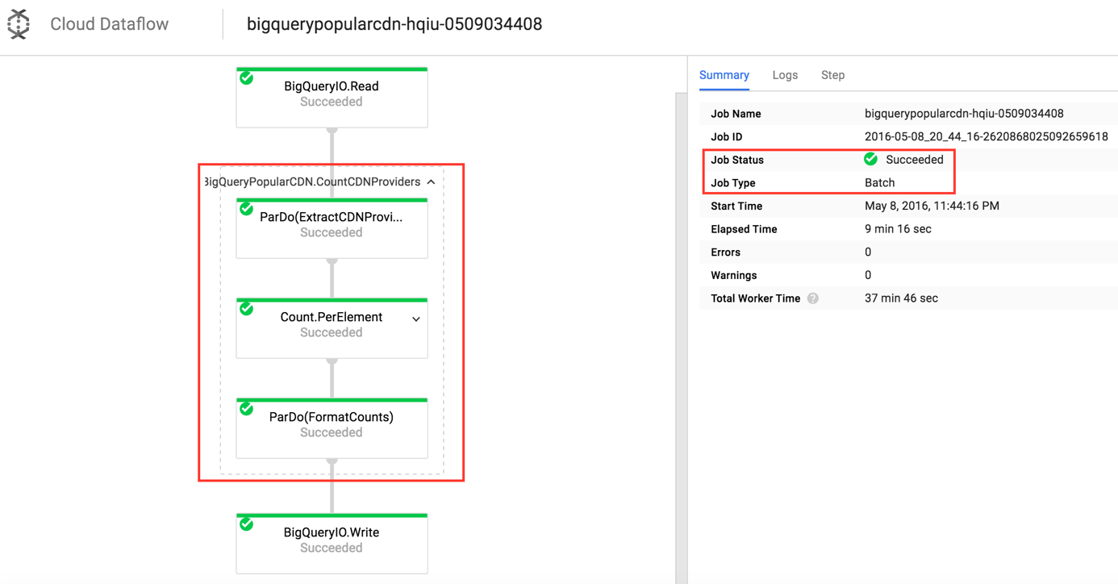

Expand **Count.PerElement**:

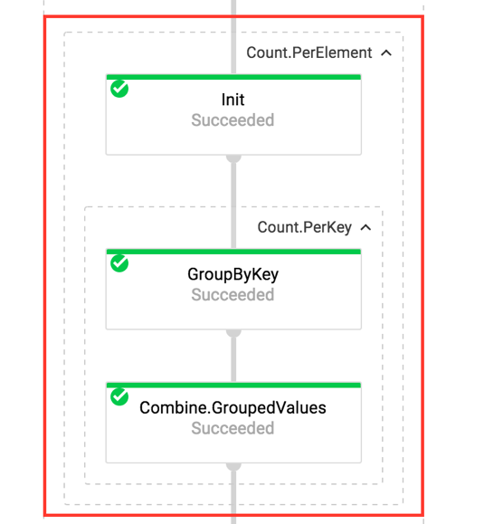

The flow structure is quite similar to the graph below:

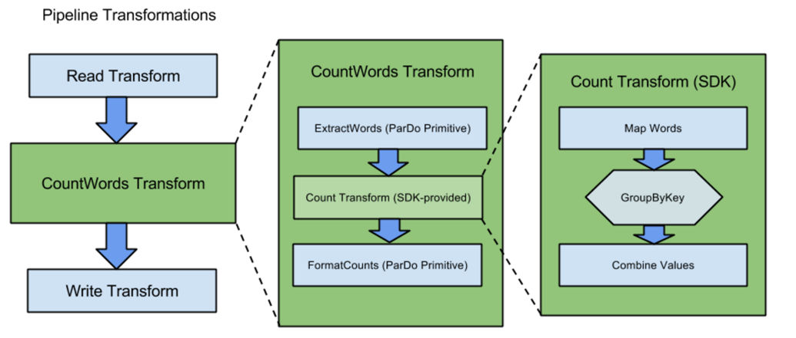

We can see the size of the collection after each transform / computation.

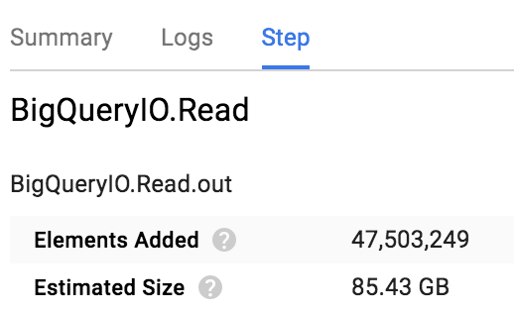 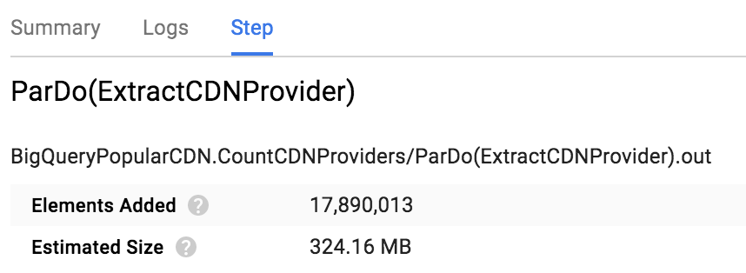

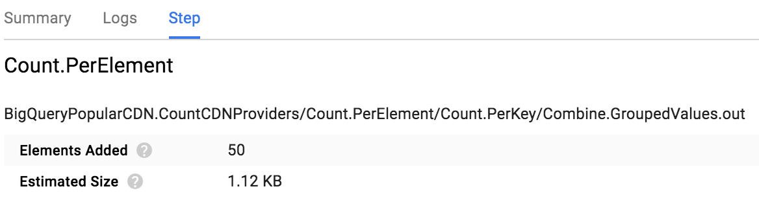

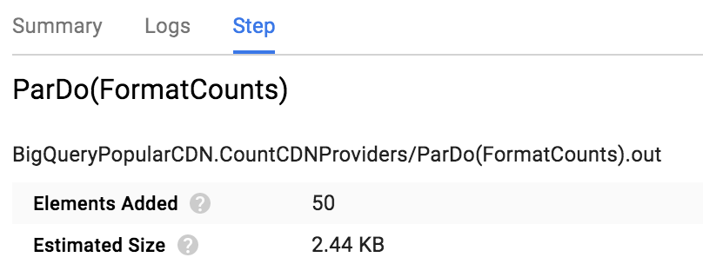

Results in Google BigQuery (Download to **CDNProviderPopularity.csv**):

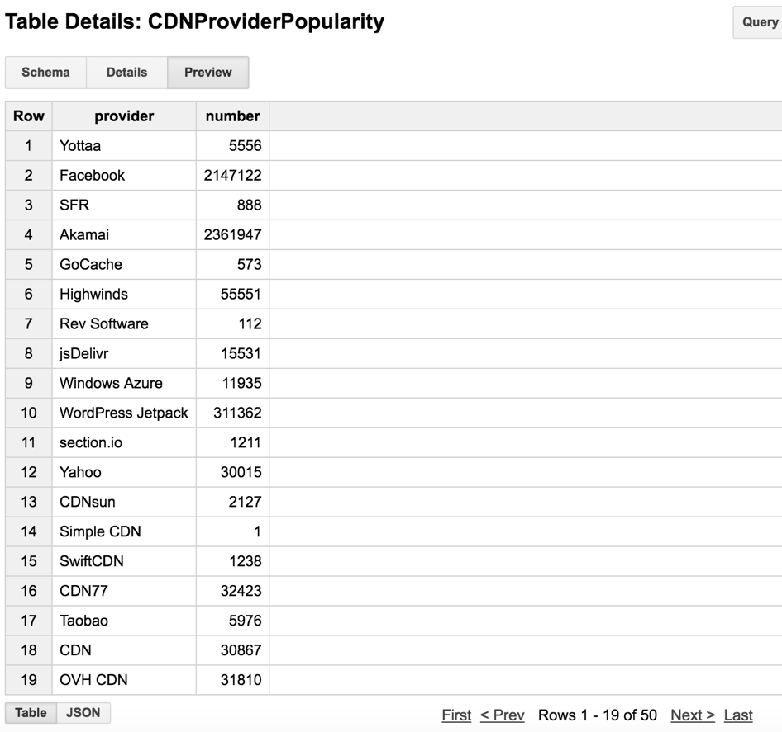

Visualize the data in D3 (Source code: **CDN_piechart.html**):

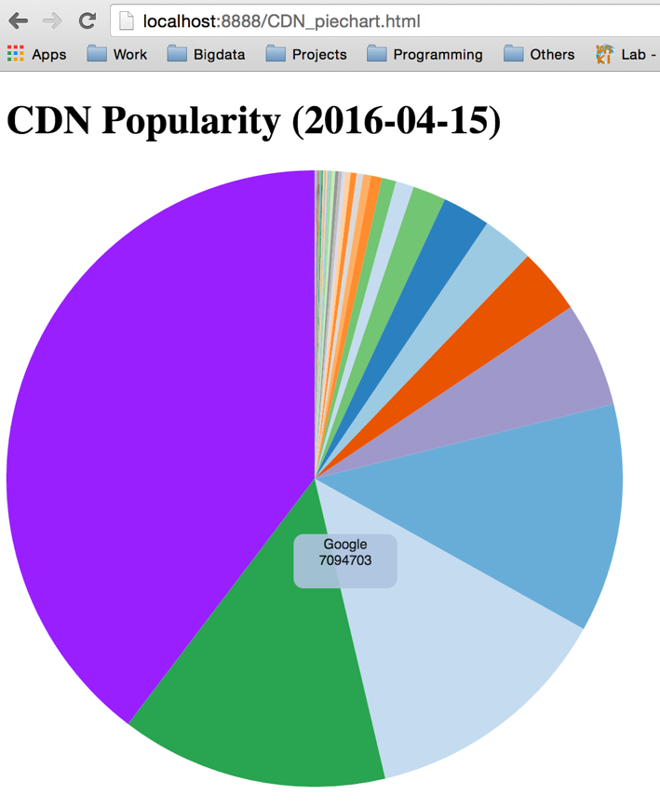

The top 5 CDN providers are: Google, Cloudflare, Akamai, Facebook, Amazon CloudFront based on the HTTP archive data from 2016-04-01 to 2016-04-15.

1. Compute the distribution of requests for different image format. We basically filter out the **image** object and count the total number of request for each specific image format. The code structure is similar to the CDN provider. I will show the different code snippet here.

Source file: ImgRqstByFormat.java

**private** **static** **final** String ***IMG_FORMAT_TABLE*** =

"gleaming-entry-130201:hqiu_httparchive_result.ImgRqstByFormat";

/**

* Examines each row (http requests reading) in the input table. Output the response

* type ('type') and the response format ('format').

*/

**static** **class** ExtractImgFormatFn **extends** DoFn<TableRow, String> {

@Override

**public** **void** processElement(ProcessContext c){

TableRow row = c.element();

String type = (String) row.get("type");

String format = (String) row.get("format");

**if** (type != **null** && format != **null**

&& type.equals("image") && ! format.isEmpty()) {

c.output(format);

}

}

}

/**

* Prepares the data for writing to BigQuery by building a TableRow object containing the

* format and the occurrences of the format.

*/

**static** **class** FormatCountsFn **extends** DoFn<KV<String, Long>, TableRow> {

@Override

**public** **void** processElement(ProcessContext c) {

TableRow row = **new** TableRow()

.set("format", c.element().getKey())

.set("number", c.element().getValue());

c.output(row);

}

}

/**

* Takes rows from a table and generates a table of counts.

*

* The output contains the total number of each image format found in each requests in

* the following schema:

* <ul>

* <li>format: string</li>

* <li>number: integer</li>

* </ul>

*/

**static** **class** CountImgFormat

**extends** PTransform<PCollection<TableRow>, PCollection<TableRow>> {

@Override

**public** PCollection<TableRow> apply(PCollection<TableRow> rows) {

// row... => Image format...

PCollection<String> ImgFormat = rows.apply(

ParDo.*of*(**new** ExtractImgFormatFn()));

// Image format... => <Image format,count>...

PCollection<KV<String, Long>> ImgFormatCounts =

ImgFormat.apply(Count.<String>*perElement*());

// <Image format,count>... => row...

PCollection<TableRow> results = ImgFormatCounts.apply(

ParDo.*of*(**new** FormatCountsFn()));

**return** results;

}

}

Results in Google BigQuery (Download to **ImgRqstByFormat.csv**):

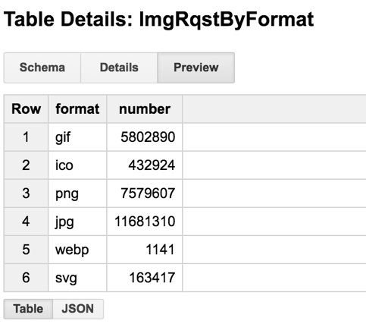

Visualize the data in D3 (Source code: **ImgRqst_piechart.html**):

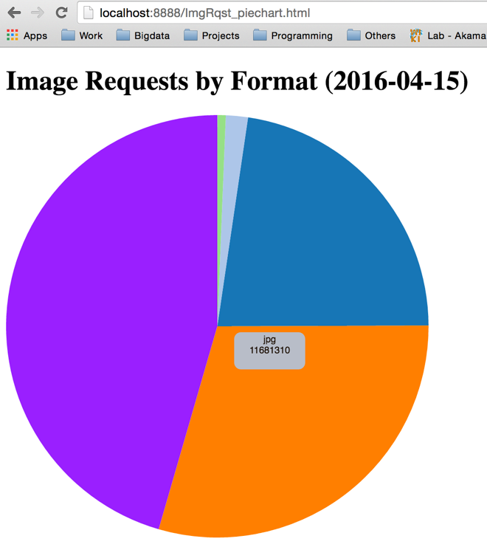

The top 3 most frequently requested image format are: jpg, png, gif.

1. Calculate the average response content length based on different content type.

The Dataflow SDKs provide a library of pre-written transforms that represent common and useful data processing operations such as performing common statistical and mathematical combinations on elements. For example, finding the sum of all elements, the mean average of all elements, or the largest/smallest of all elements in the collection like **Sum** and **Mean**.

Here we find the average response size (resp_content_length) for each object content type. The **Mean** is a statistical combination function to find the mean value per key group.

Reference link:

<https://cloud.google.com/dataflow/model/library-transforms>

Reference code:

<https://github.com/GoogleCloudPlatform/DataflowJavaSDK-examples/blob/master/src/main/java/com/google/cloud/dataflow/examples/cookbook/MaxPerKeyExamples.java>

Source file: AvgResponseSize.java

**private** **static** **final** String ***AVG_RESPONSE_SIZE_TABLE*** =

"gleaming-entry-130201:hqiu_httparchive_result.AvgResponseSize";

/**

* Examines each row (http requests reading) in the input table. Output the response content

* length ('resp_content_length') and the response type ('type').

*/

**static** **class** ExtractLengthFn **extends** DoFn<TableRow, KV<String, Integer>> {

@Override

**public** **void** processElement(ProcessContext c) {

TableRow row = c.element();

String type = (String) row.get("type");

String length = (String) row.get("resp_content_length");

// Escape invalid content length

**if** (length.contains(";") || length.contains(" ") || length.contains(",")

|| (length.length() >= 10 && length.charAt(0) > '1')) {

**return**;

}

**if** (type != **null** && ! type.isEmpty() && length != **null** && !length.isEmpty()) {

Integer contentlen = Integer.*parseInt*(length);

c.output(KV.*of*(type, contentlen));

}

}

}

To **DoFn** outputs key value pairs, which is (content type, response content length).

/**

* Format the results to a TableRow, to save to BigQuery.

*

*/

**static** **class** FormatMeanFn **extends** DoFn<KV<String, Double>, TableRow> {

@Override

**public** **void** processElement(ProcessContext c) {

TableRow row = **new** TableRow()

.set("type", c.element().getKey())

.set("avg_content_length", c.element().getValue() / 1024);

c.output(row);

}

}

/**

* Reads rows from http archive table, and finds the average resp_content_length for each

* type via the 'Mean' statistical combination function.

*/

**static** **class** MeanContentLength

**extends** PTransform<PCollection<TableRow>, PCollection<TableRow>> {

@Override

**public** PCollection<TableRow> apply(PCollection<TableRow> rows) {

// row... => <type, resp_content_length> ...

PCollection<KV<String, Integer>> length = rows.apply(

ParDo.*of*(**new** ExtractLengthFn()));

// type, resp_content_length... => <type, mean resp_content_length>...

PCollection<KV<String, Double>> meanLength =

length.apply(Mean.<String, Integer>*perKey*());

// <type, mean>... => row...

PCollection<TableRow> results = meanLength.apply(

ParDo.*of*(**new** FormatMeanFn()));

**return** results;

}

}

**Mean** computes the arithmetic mean the mean of the values associated with each key in a **PCollection** of KVs.

Results in Google BigQuery (Download to **AvgResponseSize.csv**):

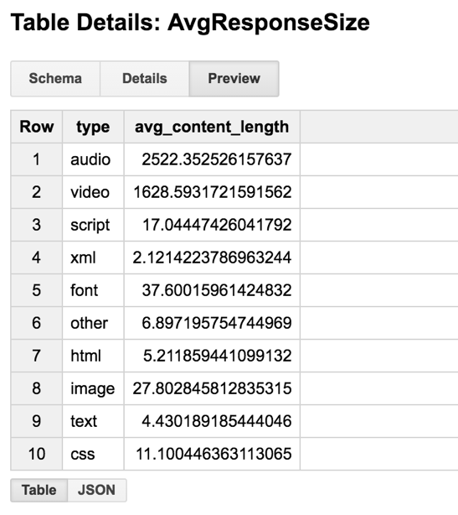

Visualize the data in D3 (Source code: **AvgRespSize_barchart.html**):

The audio and video objects have significant large size than others.

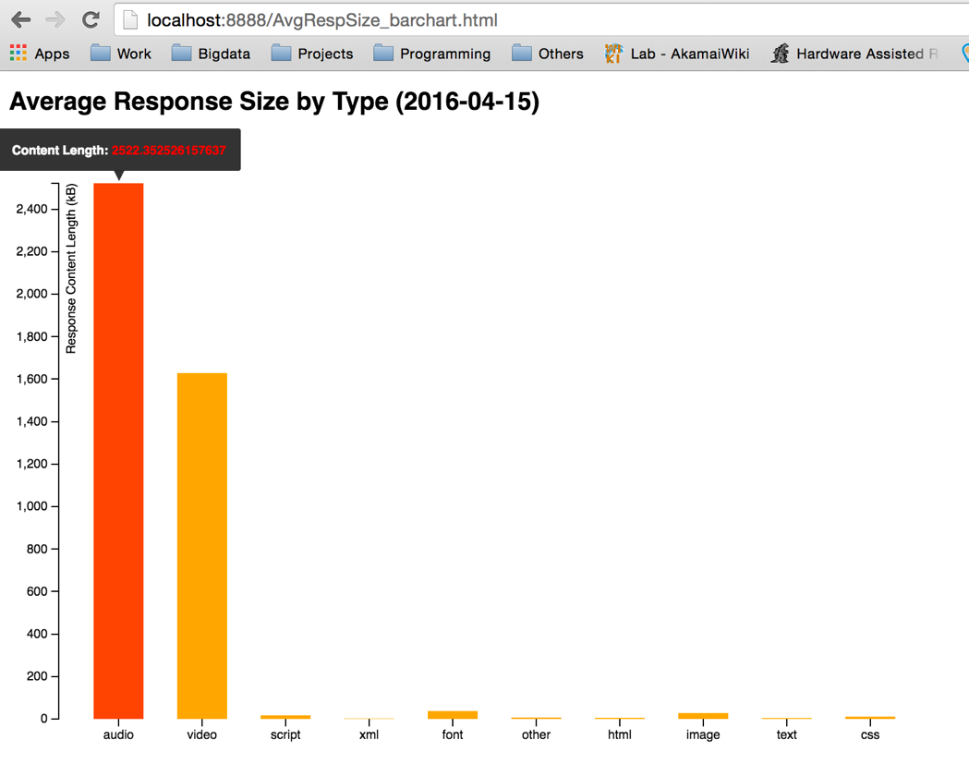

Since the dataset is quite large (40+GB), it’s takes server minutes for processing and makes debugging very hard. Here is the trick to select a small dataset for testing and processing:

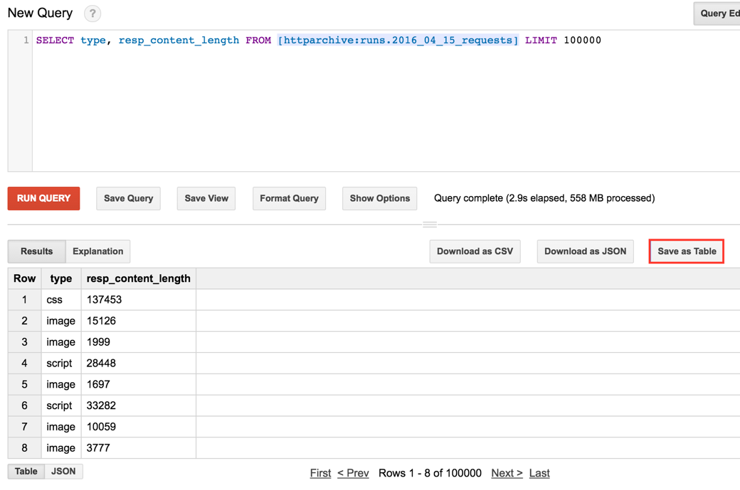

Select some columns or rows and save to my own table in BigQuery. Then we can read from our own table by using:

**private** **static** **final** String ***HTTP_ARCHIVE_TABLE*** =

// "httparchive:runs.2016_04_15_requests";

"gleaming-entry-130201:hqiu_httparchive_result.2016_04_15_selected_resp";

From the Eclipse console, we can also see some autoscaling done by Dataflow.

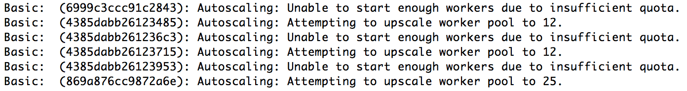

1. Use Dataflow pipeline derived data as a side input to filter image object in a specific format whose size is larger than global mean length of all image objects. Here we will try some different shape of pipeline that we can use.

Branching **PCollections**:

* Multiple transforms process the same PCollection (left graph).
* A single transform that uses side outputs (right graph).

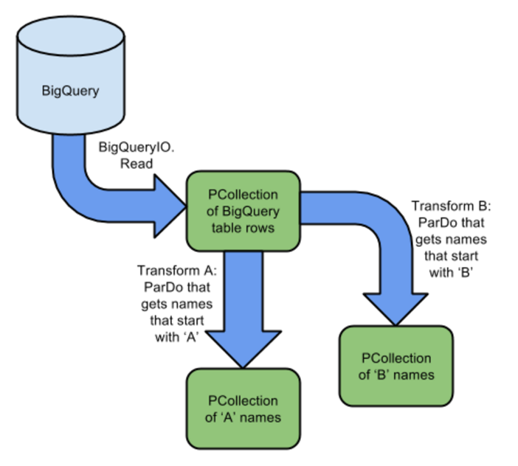 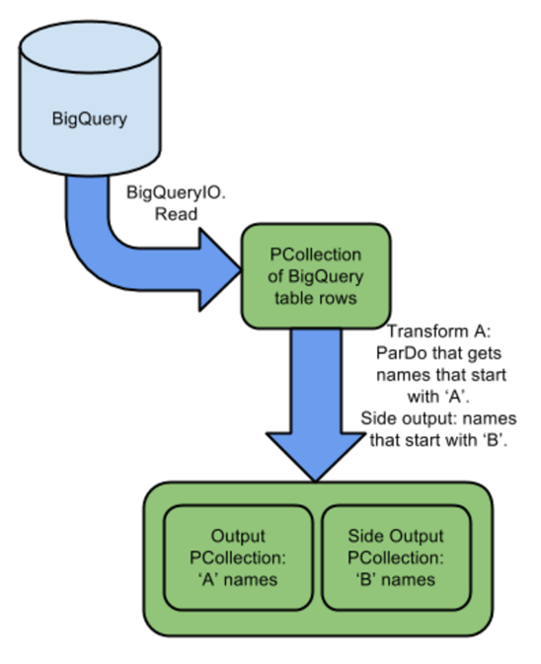

We will use the global mean length of all image objects as a side input, and filter out the image objects in “svg” format whose size is larger than this mean value.

Reference code:

<https://github.com/GoogleCloudPlatform/DataflowJavaSDK-examples/blob/master/src/main/java/com/google/cloud/dataflow/examples/cookbook/FilterExamples.java>

Source file: FilterImgObjSize.java

**public** **class** FilterImgObjSize {

// Default data set: httparchive:runs.2016_04_15_requests

**private** **static** **final** String ***HTTP_ARCHIVE_TABLE*** =

"httparchive:runs.2016_04_15_requests";

// "gleaming-entry-130201:hqiu_httparchive_result.2016_04_15_requests_sample";

**private** **static** **final** String ***IMG_OBJ_SIZE_TABLE*** =

"gleaming-entry-130201:hqiu_httparchive_result.FilterImgObjSize";

**static** **final** Logger ***LOG*** = Logger.*getLogger*(FilterImgObjSize.**class**.getName());

**static** **final** String ***FORMAT_TO_FILTER*** = "svg";

/**

* Examines each row in the input table. Outputs only the subset of the cells this example

* is interested in-- the type, format, and resp_content_length -- as a bigquery table row.

*/

**static** **class** ProjectionFn **extends** DoFn<TableRow, TableRow> {

@Override

**public** **void** processElement(ProcessContext c){

TableRow row = c.element();

// Grab type, format, and resp_content_length from the row

String type = (String) row.get("type");

String format = (String) row.get("format");

String length = (String) row.get("resp_content_length");

// Escape invalid content length

**if** (length.contains(";") || length.contains(" ") || length.contains(",")

|| (length.length() >= 10 && length.charAt(0) > '1')) {

**return**;

}

// Prepares the data for writing to BigQuery by building a TableRow object

**if** (type != **null** && type.equals("image")

&& format != **null** && ! format.isEmpty()

&& length != **null** && ! length.isEmpty()) {

TableRow outRow = **new** TableRow()

.set("type", type)

.set("format", format)

.set("length", length);

c.output(outRow);

}

}

}

/**

* Implements 'filter' functionality.

*

* <p>Examines each row in the input table. Outputs only rows from the format

* formatFilter, which is passed in as a parameter during construction of this DoFn.

*/

**static** **class** FilterSingleFormatDataFn **extends** DoFn<TableRow, TableRow> {

String formatFilter;

**public** FilterSingleFormatDataFn(String formatFilter) {

**this**.formatFilter = formatFilter;

}

@Override

**public** **void** processElement(ProcessContext c){

TableRow row = c.element();

String format = (String) row.get("format");

**if** (format.equals(**this**.formatFilter)) {

c.output(row);

}

}

}

/**

* Examines each row (weather reading) in the input table. Output the temperature

* reading for that row ('mean_temp').

*/

**static** **class** ExtractLengthFn **extends** DoFn<TableRow, Double> {

@Override

**public** **void** processElement(ProcessContext c){

TableRow row = c.element();

Double contentLength = Double.*parseDouble*((String) row.get("length"));

c.output(contentLength);

}

}

/*

* Finds the global mean of the mean_length for each record, and outputs

* only data that has a mean content length larger than this global mean.

**/

**static** **class** BelowGlobalMean

**extends** PTransform<PCollection<TableRow>, PCollection<TableRow>> {

String formatFilter;

**public** BelowGlobalMean(String formatFilter) {

**this**.formatFilter = formatFilter;

}

@Override

**public** PCollection<TableRow> apply(PCollection<TableRow> rows) {

// Extract the resp_content_length from each row.

PCollection<Double> length = rows.apply(

ParDo.*of*(**new** ExtractLengthFn()));

// Find the global mean, of all the resp_content_length readings,

// and prepare this singleton PCollectionView for use as a side input.

**final** PCollectionView<Double> globalMeanLength =

length.apply(Mean.<Double>*globally*())

.apply(View.<Double>*asSingleton*());

// Rows filtered to remove all but a single format

PCollection<TableRow> formatFilteredRows = rows

.apply(ParDo.*of*(**new** FilterSingleFormatDataFn(formatFilter)));

// Then, use the global mean as a side input, to further filter the data.

// By using a side input to pass in the filtering criteria, we can use a value

// that is computed earlier in pipeline execution.

// We'll only output readings with temperatures below this mean.

PCollection<TableRow> filteredRows = formatFilteredRows

.apply(ParDo

.*named*("ParseAndFilter")

.withSideInputs(globalMeanLength)

.of(**new** DoFn<TableRow, TableRow>() {

@Override

**public** **void** processElement(ProcessContext c) {

Double contentLength = Double.*parseDouble*(c.element().get("length").toString());

Double gLenth = c.sideInput(globalMeanLength);

**if** (contentLength > gLenth) {

c.output(c.element());

}

}

}));

**return** filteredRows;

}

}

/**

* Options supported by {@link FilterImgObjSize}.

*

* <p>Inherits standard configuration options.

*/

**private** **static** **interface** Options **extends** PipelineOptions {

@Description("Table to read from, specified as "

+ "<project_id>:<dataset_id>.<table_id>")

@Default.String(***HTTP_ARCHIVE_TABLE***)

String getInput();

**void** setInput(String value);

@Description("Table to write to, specified as "

+ "<project_id>:<dataset_id>.<table_id>. "

+ "The dataset_id must already exist")

@Default.String(***IMG_OBJ_SIZE_TABLE***)

@Validation.Required

String getOutput();

**void** setOutput(String value);

@Description("Numeric value of format to filter on")

@Default.String(***FORMAT_TO_FILTER***)

String getFormatFilter();

**void** setFormatFilter(String value);

}

/**

* Helper method to build the table schema for the output table.

*/

**private** **static** TableSchema buildOutputSchemaProjection() {

List<TableFieldSchema> fields = **new** ArrayList<>();

fields.add(**new** TableFieldSchema().setName("type").setType("STRING"));

fields.add(**new** TableFieldSchema().setName("format").setType("STRING"));

fields.add(**new** TableFieldSchema().setName("length").setType("FLOAT"));

TableSchema schema = **new** TableSchema().setFields(fields);

**return** schema;

}

**public** **static** **void** main(String[] args)

**throws** Exception {

Options options = PipelineOptionsFactory.*fromArgs*(args).withValidation().as(Options.**class**);

Pipeline p = Pipeline.*create*(options);

TableSchema schema = *buildOutputSchemaProjection*();

p.apply(BigQueryIO.Read.*from*(options.getInput()))

.apply(ParDo.*of*(**new** ProjectionFn()))

.apply(**new** BelowGlobalMean(options.getFormatFilter()))

.apply(BigQueryIO.Write

.*to*(options.getOutput())

.withSchema(schema)

.withCreateDisposition(BigQueryIO.Write.CreateDisposition.***CREATE_IF_NEEDED***)

.withWriteDisposition(BigQueryIO.Write.WriteDisposition.***WRITE_TRUNCATE***));

p.run();

}

}

Dataflow structure:

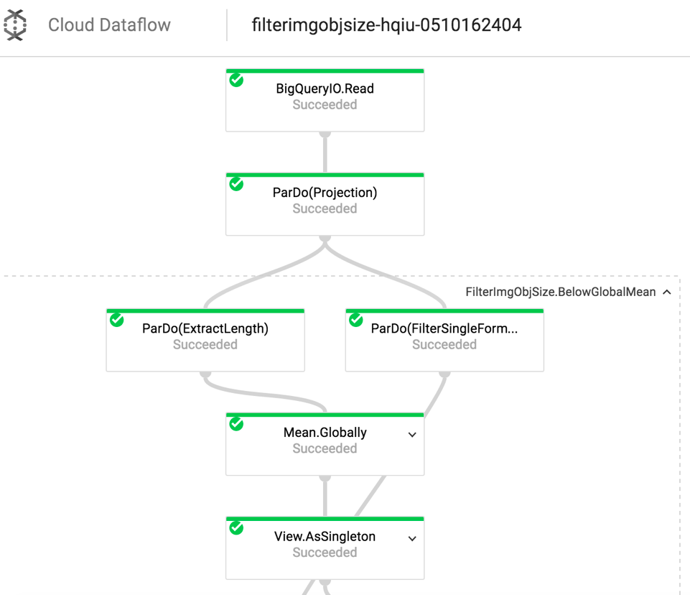

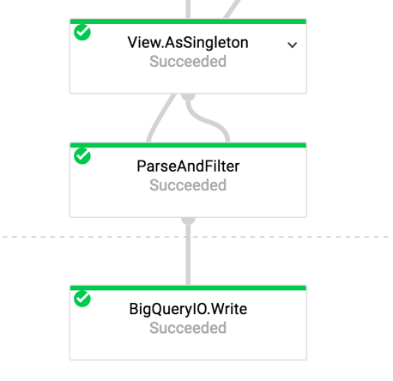

The **Mean.globally** becomes a side input of **ParseAndFilter**.

Results in Google BigQuery (Download to **FilterImgObjSize.csv**):

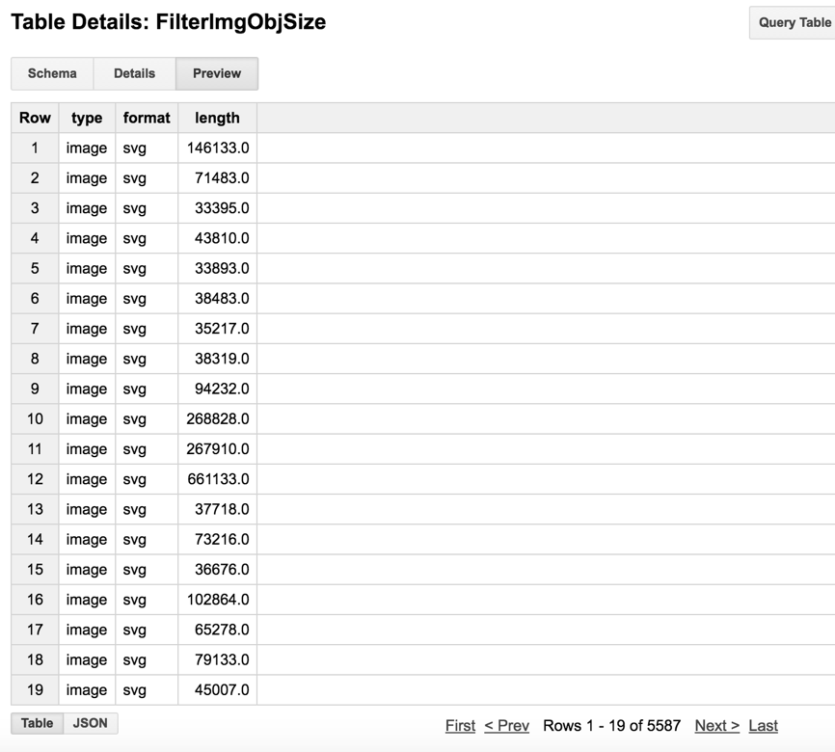

The filtered object size (in bytes) is fairly large. (Average image size is 27 kB).

1. Use Dataflow time-based windowing model to aggregate total number of requests per page. The total number of requests per page is basically the total occurrences of each page id.

Normal implementation without using windowing:

Source file: RqstsPerPage.java

/**

* Examines each row in the input table. If a page id is recorded

* in that sample, the name of page id is the output.

*/

**static** **class** ExtractPageidFn **extends** DoFn<TableRow, String> {

@Override

**public** **void** processElement(ProcessContext c){

TableRow row = c.element();

c.output((String) row.get("pageid"));

}

}

/**

* Prepares the data for writing to BigQuery by building a TableRow object containing the

* page id and the occurrences of the page id.

*/

**static** **class** FormatCountsFn **extends** DoFn<KV<String, Long>, TableRow> {

@Override

**public** **void** processElement(ProcessContext c) {

TableRow row = **new** TableRow()

.set("pageid", c.element().getKey())

.set("rqsts_per_page", c.element().getValue());

c.output(row);

}

}

/**

* Takes rows from a table and generates a table of counts.

*

* The output contains the total number of requests found in each page id in

* the following schema:

* <ul>

* <li>pageid: string</li>

* <li>number: integer</li>

* </ul>

*/

**static** **class** CountRqstsPerPage

**extends** PTransform<PCollection<TableRow>, PCollection<TableRow>> {

@Override

**public** PCollection<TableRow> apply(PCollection<TableRow> rows) {

// row... => page id...

PCollection<String> page = rows.apply(

ParDo.*of*(**new** ExtractPageidFn()));

// page id... => <page id,count>...

PCollection<KV<String, Long>> pageCounts =

page.apply(Count.<String>*perElement*());

// <page id,count>... => row...

PCollection<TableRow> results = pageCounts.apply(

ParDo.*of*(**new** FormatCountsFn()));

**return** results;

}

}

Results in Google BigQuery (Download to **RqstsPerPage.csv**):

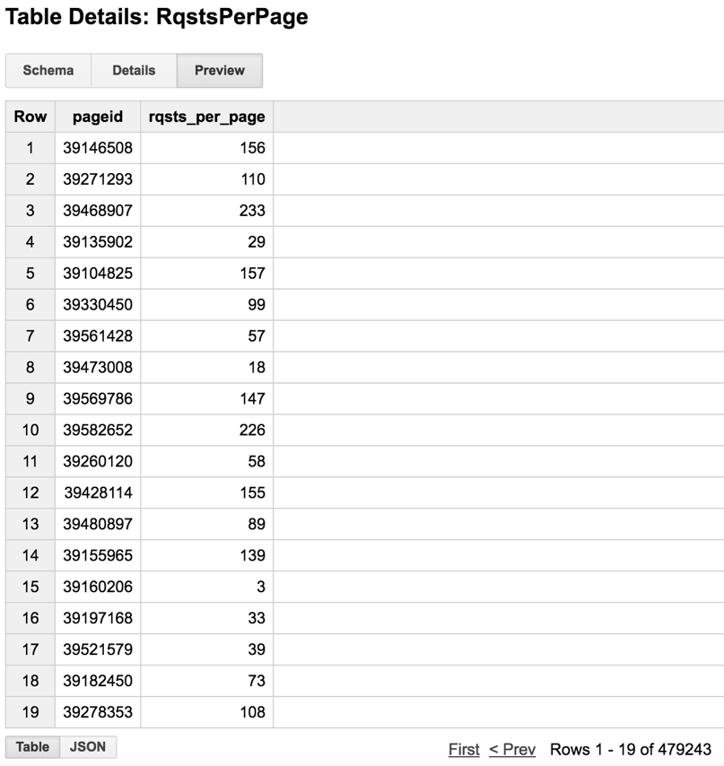

Implement using **Windowing** model:

Reference:

<https://cloud.google.com/dataflow/model/windowing>

Reference code:

<https://github.com/GoogleCloudPlatform/DataflowJavaSDK-examples/blob/master/src/main/java/com/google/cloud/dataflow/examples/WindowedWordCount.java>

The Dataflow SDKs use **Windowing** to subdivide a **PCollection** according to the timestamps of its individual elements. Dataflow transforms that aggregate multiple elements, such as GroupByKey and Combine, work implicitly on a per-window.

**Windowing** is most useful with an unbounded **PCollection**, which represents a continuously updating data set of unknown/unlimited size (e.g. streaming data). They process each **PCollection** as a succession of multiple, finite windows, though the entire collection itself may be of unlimited or infinite size.

Here we can use windowing with fixed-size data sets in **bounded PCollections**. From the official documentation, it says that windowing considers only the implicit timestamps attached to each element of a PCollection, and data sources that create fixed data sets (such as TextIO and BigQueryIO) assign the same timestamp to every element. This means that all the elements are by default part of a single, global window. Having all elements assigned to the same window will cause a pipeline to execute in classic MapReduce batch style.

To use windowing with fixed data sets, following the windowed word count example, we can assign our own timestamps to each element. To assign timestamps to elements, we can use a ParDo transform with a DoFn that outputs each element with a new timestamp.

The pipeline will create a bounded **PCollection** of key/value pairs. Then we can set a **windowing** function for that **PCollection**. The **GroupByKey** transform now groups the elements of the PCollection by both **key and window**. The subsequent ParDo transform gets applied multiple times per key, once for each window.

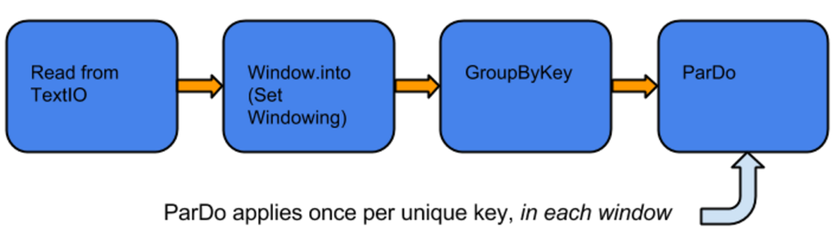

The window types can be:

* Fixed Time Windows
* Sliding Time Windows
* Per-Session Windows
* Single Global Window

Here we will try the most simple form: a fixed time windows. Given a timestamped PCollection, which might be continously updating, each window might capture a certain time interval of elements.

Consider a window that operates at five-minute intervals: all of the elements in your unbounded PCollection with timestamp values between 0:00:00 and 0:04:59 belong to the first window, elements with timestamp values between 0:05:00 and 0:09:59 belong to the second window, and so on.

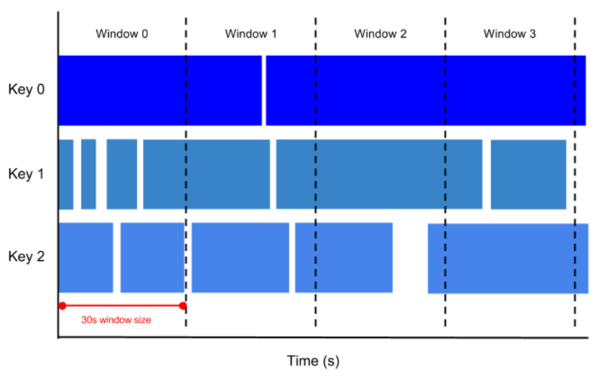

**public** **class** WindowedRqstsPerPage {

// Default data set: httparchive:runs.2016_04_15_requests

**private** **static** **final** String ***HTTP_ARCHIVE_TABLE*** =

"httparchive:runs.2016_04_15_requests";

// "gleaming-entry-130201:hqiu_httparchive_result.2016_04_15_requests_sample";

**private** **static** **final** String ***WINDOWED_RQST_PER_PAGE_TABLE*** =

"gleaming-entry-130201:hqiu_httparchive_result.WindowedRqstsPerPage";

**private** **static** **final** Logger ***LOG*** = LoggerFactory.*getLogger*(WindowedRqstsPerPage.**class**);

**static** **final** **int** ***WINDOW_SIZE*** = 20; // Default window duration in minutes

**static** **class** AddTimestampFn **extends** DoFn<TableRow, String> {

**private** **static** **final** **long** ***RAND_RANGE*** = 3600000; // 1 hours in ms

@Override

**public** **void** processElement(ProcessContext c) {

TableRow row = c.element();

String pageid = (String) row.get("pageid");

// Generate a timestamp that falls somewhere in the past hour.

**long** randomTimestamp = System.*currentTimeMillis*()

- (**int**) (Math.*random*() * ***RAND_RANGE***);

/**

* Concept #2: Set the data element with that timestamp.

*/

c.outputWithTimestamp(pageid, **new** Instant(randomTimestamp));

}

}

**static** **class** ExtractPageidFn **extends** DoFn<String, String> {

@Override

**public** **void** processElement(ProcessContext c){

String pageid = c.element();

c.output(pageid);

}

}

**static** **class** CountRqstsPerPage **extends** PTransform<PCollection<String>,

PCollection<KV<String, Long>>> {

@Override

**public** PCollection<KV<String, Long>> apply(PCollection<String> lines) {

// Convert lines of text into individual page id.

PCollection<String> pageid = lines.apply(

ParDo.*of*(**new** ExtractPageidFn()));

// Count the number of times each page id occurs.

PCollection<KV<String, Long>> rqstCounts =

pageid.apply(Count.<String>*perElement*());

**return** rqstCounts;

}

}

/** A DoFn that converts a page id and Count into a BigQuery table row. */

**static** **class** FormatAsTableRowFn **extends** DoFn<KV<String, Long>, TableRow> {

@Override

**public** **void** processElement(ProcessContext c) {

TableRow row = **new** TableRow()

.set("pageid", c.element().getKey())

.set("count", c.element().getValue())

// include a field for the window timestamp

.set("window_timestamp", c.timestamp().toString());

c.output(row);

}

}

/**

* Helper method that defines the BigQuery schema used for the output.

*/

**private** **static** TableSchema getSchema() {

List<TableFieldSchema> fields = **new** ArrayList<>();

fields.add(**new** TableFieldSchema().setName("pageid").setType("INTEGER"));

fields.add(**new** TableFieldSchema().setName("count").setType("INTEGER"));

fields.add(**new** TableFieldSchema().setName("window_timestamp").setType("TIMESTAMP"));

TableSchema schema = **new** TableSchema().setFields(fields);

**return** schema;

}

/**

* Concept #6: We'll stream the results to a BigQuery table. The BigQuery output source is one

* that supports both bounded and unbounded data. This is a helper method that creates a

* TableReference from input options, to tell the pipeline where to write its BigQuery results.

*/

**private** **static** TableReference getTableReference(Options options) {

TableReference tableRef = **new** TableReference();

tableRef.setProjectId(options.getProject());

tableRef.setDatasetId(options.getBigQueryDataset());

tableRef.setTableId(options.getBigQueryTable());

**return** tableRef;

}

/**

* Options supported by {@link WindowedRqstsPerPage}.

*

* <p>Inherits standard example configuration options, which allow specification of the BigQuery

* table and the PubSub topic, as well as the {@link WordCount.WordCountOptions} support for

* specification of the input file.

*/

**public** **static** **interface** Options

**extends** PipelineOptions, DataflowExampleUtils.DataflowExampleUtilsOptions {

@Description("Fixed window duration, in minutes")

@Default.Integer(***WINDOW_SIZE***)

Integer getWindowSize();

**void** setWindowSize(Integer value);

@Description("Table to read from, specified as "

+ "<project_id>:<dataset_id>.<table_id>")

@Default.String(***HTTP_ARCHIVE_TABLE***)

String getInput();

**void** setInput(String value);

@Description("BigQuery table to write to, specified as "

+ "<project_id>:<dataset_id>.<table_id>. The dataset must already exist.")

@Default.String(***WINDOWED_RQST_PER_PAGE_TABLE***)

@Validation.Required

String getOutput();

**void** setOutput(String value);

@Description("Whether to run the pipeline with unbounded input")

// @Default.Boolean(value = true)

**boolean** isUnbounded();

**void** setUnbounded(**boolean** value);

}

**public** **static** **void** main(String[] args) **throws** IOException {

Options options = PipelineOptionsFactory.*fromArgs*(args).withValidation().as(Options.**class**);

options.setBigQuerySchema(*getSchema*());

// DataflowExampleUtils creates the necessary input sources to simplify execution of this

// Pipeline.

DataflowExampleUtils exampleDataflowUtils = **new** DataflowExampleUtils(options,

options.isUnbounded());

Pipeline pipeline = Pipeline.*create*(options);

/**

* Concept #1: the Dataflow SDK lets us run the same pipeline with either a bounded or

* unbounded input source.

*/

PCollection<String> input;

**if** (options.isUnbounded()) {

***LOG***.info("Reading from PubSub.");

/**

* Concept #3: Read from the PubSub topic. A topic will be created if it wasn't

* specified as an argument. The data elements' timestamps will come from the pubsub

* injection.

*/

input = pipeline

.apply(PubsubIO.Read.*topic*(options.getPubsubTopic()));

} **else** {

/** Else, this is a bounded pipeline. Read from the GCS file. */

input = pipeline

.apply(BigQueryIO.Read.*from*(options.getInput()))

// Concept #2: Add an element timestamp, using an artificial time just to show windowing.

// See AddTimestampFn for more detail on this.

.apply(ParDo.*of*(**new** AddTimestampFn()));

}

/**

* Concept #4: Window into fixed windows. The fixed window size for this example defaults to 10

* minute (you can change this with a command-line option). See the documentation for more

* information on how fixed windows work, and for information on the other types of windowing

* available (e.g., sliding windows).

*/

PCollection<String> windowedRqsts = input

.apply(Window.<String>*into*(

FixedWindows.*of*(Duration.*standardMinutes*(options.getWindowSize()))));

/**

* Concept #5: Re-use our existing CountWords transform that does not have knowledge of

* windows over a PCollection containing windowed values.

*/

PCollection<KV<String, Long>> rqstsCounts = windowedRqsts.apply(**new** CountRqstsPerPage());

/**

* Concept #6: Format the results for a BigQuery table, then write to BigQuery.

* The BigQuery output source supports both bounded and unbounded data.

*/

rqstsCounts.apply(ParDo.*of*(**new** FormatAsTableRowFn()))

.apply(BigQueryIO.Write.*to*(*getTableReference*(options)).withSchema(*getSchema*()));

PipelineResult result = pipeline.run();

exampleDataflowUtils.mockUnboundedSource(options.getInput(), result);

}

}

File structure (Need the libs in my.java.packageid.common to run the code):

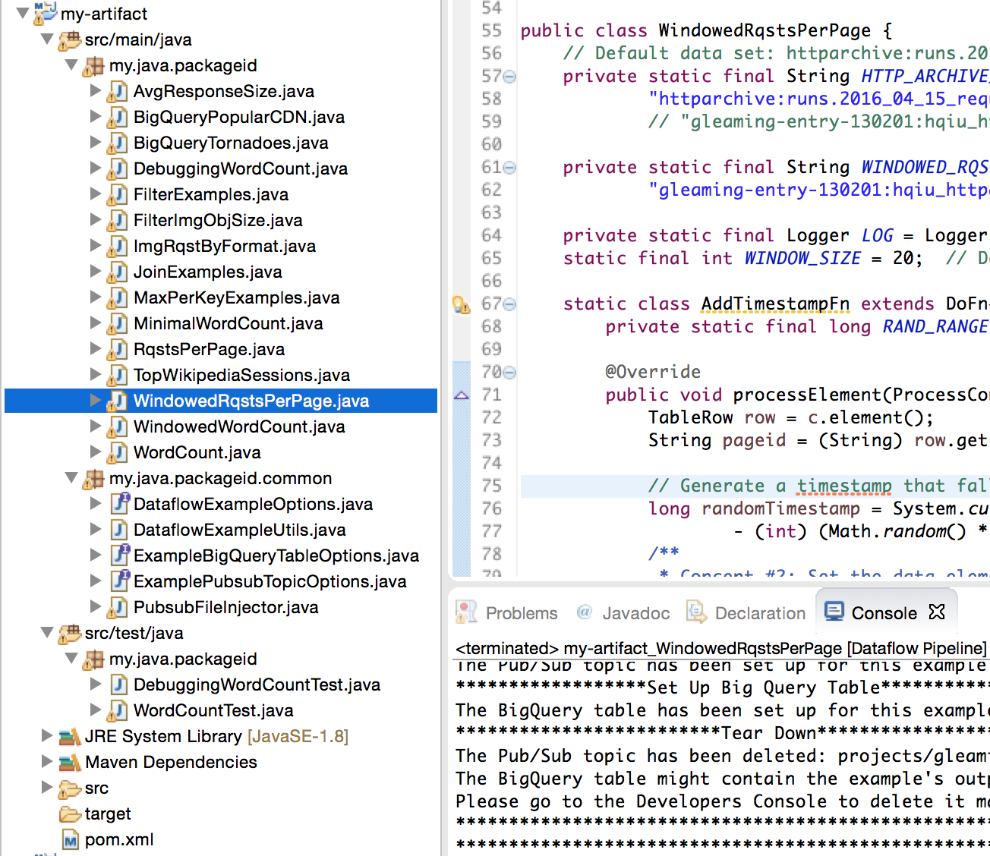

Dataflow structure:

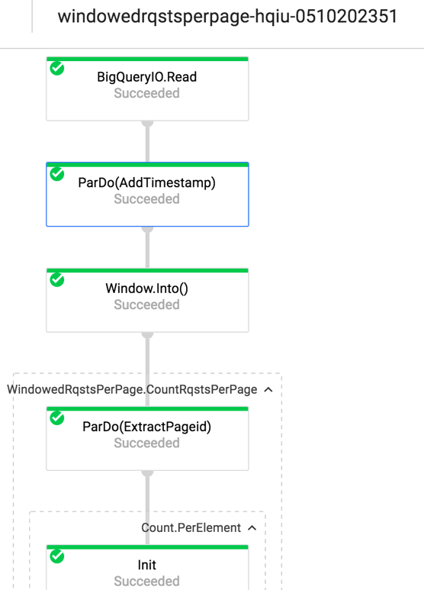 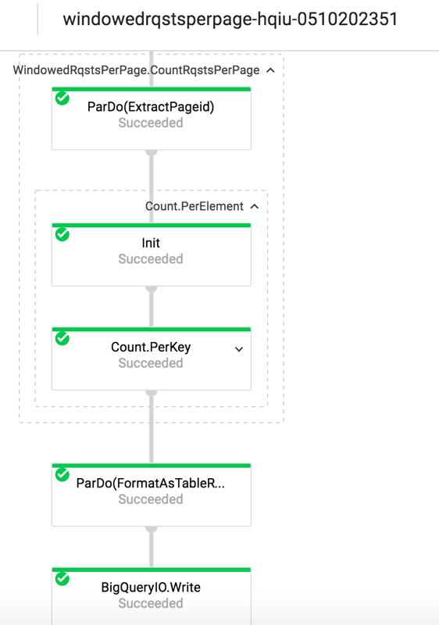

Results in Google BigQuery (Download to **WindowedRqstsPerPage.csv**):

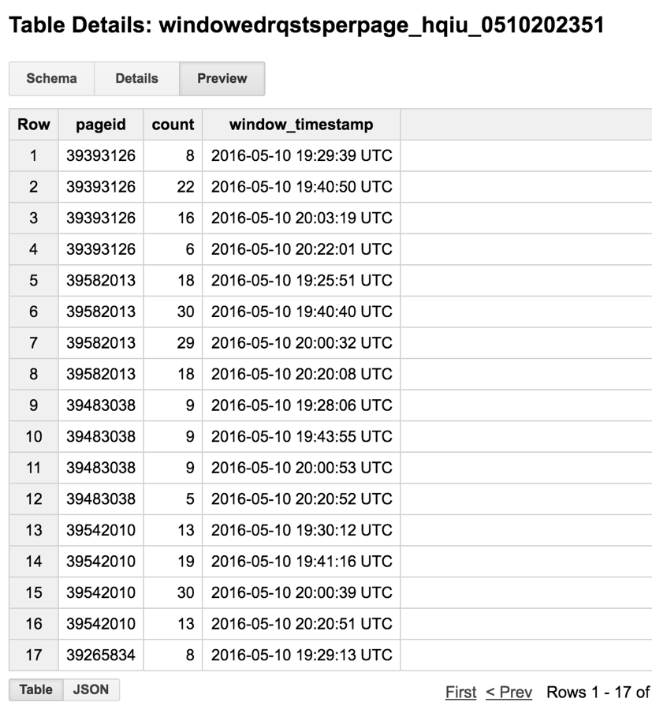

We can see that each **pageid** is processed by both **key** and **window**.

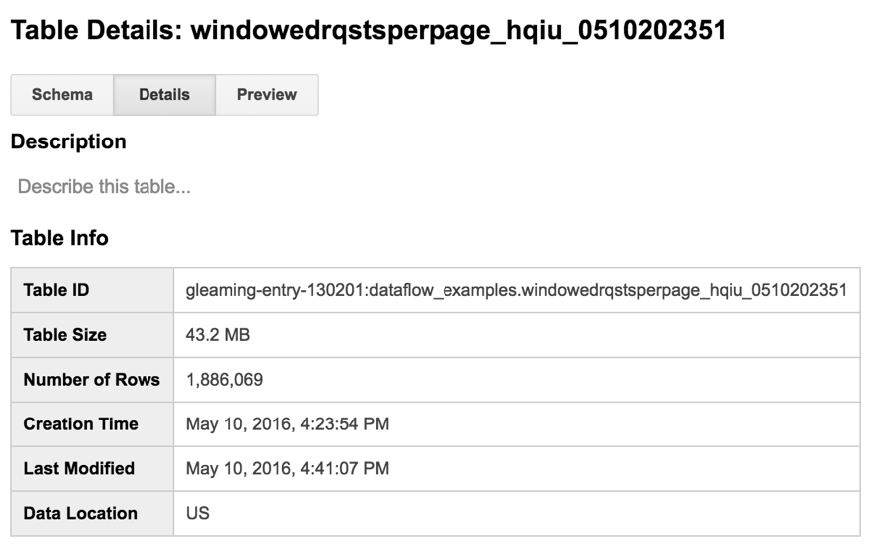

The table is automatically generated. Once it is created, the data is processed and written into the table in real-time.

Validate the results. We can see that for the same **pageid**, the sum of requests from all windows is exactly the same with the result got from the non-windowing model. Since we use fixed time windows, there’s no overlap between windows.

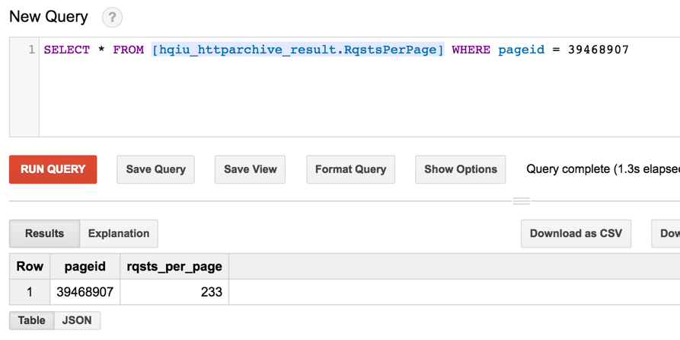

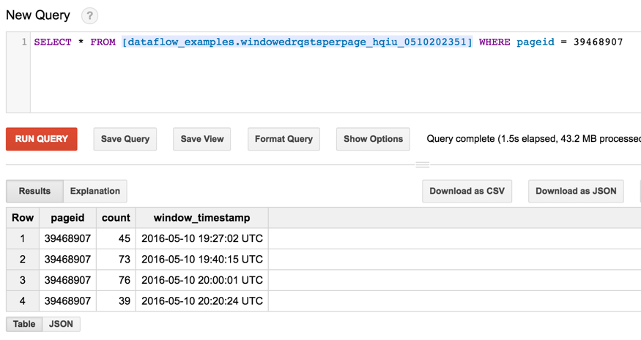

45 + 73 + 76 + 39 = 233

This code can interact with Google Pub/Sub too for real unbounded streaming. Due to limited time, I will dig into them later. Also, I can try the sliding window and some triggers.

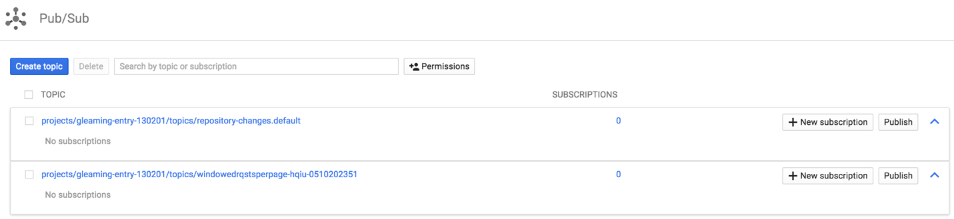

**Summary**

The Google Cloud Dataflow is a very powerful and fully-managed cloud service for batch and streaming big data processing. In this project, we’ve built our own linear and more complex pipelines to process massive HTTP Archive data using Google Cloud SDK. We’ve also learned and practiced the Dataflow programming model. We’ve got to know the Internet trend from many interesting findings such as popular CDN providers, average response content length. There’s still a lot to explore such as more complicated windowing model, triggers and performance comparison with other data processing models. The official research paper is quite worth reading.

**References**

Google Cloud Dataflow documentation:

<https://cloud.google.com/dataflow/docs/>

Examples of the Cloud Dataflow SDK for Java:

<https://github.com/GoogleCloudPlatform/DataflowJavaSDK-examples>

Complete end-to-end example pipelines that perform complex data processing tasks:

<https://github.com/GoogleCloudPlatform/DataflowJavaSDK/tree/master/examples/src/main/java/com/google/cloud/dataflow/examples/complete>

Simple "cookbook" examples, which show how to define commonly-used data analysis patterns that you would likely incorporate into a larger Dataflow pipeline:

<https://github.com/GoogleCloudPlatform/DataflowJavaSDK/tree/master/examples/src/main/java/com/google/cloud/dataflow/examples/cookbook>

Google Dataflow model research paper:

<http://research.google.com/pubs/pub43864.html>